UNITED STATES

SECURITIES AND EXCHANGE COMMISSION

Washington, D.C. 20549

FORM 8-K

CURRENT REPORT

Pursuant to Section 13 or 15(d)

of the Securities Exchange Act of 1934

Date of Report (Date of earliest event reported): June 13, 2026

RHYTHM PHARMACEUTICALS, INC.

(Exact name of registrant as specified in its charter)

Delaware | 001-38223 | 46-2159271
(State or other jurisdiction | (Commission | (IRS Employer
of incorporation) | File Number) | Identification Number)
 | 222 Berkeley Street
 | 12th Floor
 | Boston, MA 02116
 | (Address of principal executive offices) (Zip Code)
 | Registrant’s telephone number, including area code: (857) 264-4280
 | N/A
 | (Former name or former address, if changed since last report)

Check the appropriate box below if the Form 8-K filing is intended to simultaneously satisfy the filing obligation of the registrant under any of the following provisions:

- Written communications pursuant to Rule 425 under the Securities Act (17 CFR 230.425)

- Soliciting material pursuant to Rule 14a-12 under the Exchange Act (17 CFR 240.14a-12)

- Pre-commencement communications pursuant to Rule 14d-2(b) under the Exchange Act (17 CFR 240.14d-2(b))

- Pre-commencement communications pursuant to Rule 13e-4(c) under the Exchange Act (17 CFR 240.13e-4(c))

Securities registered pursuant to Section 12(b) of the Act:

Title of each class | Trading | Name of each exchange on which registered
Title of each class | Symbol(s) | Name of each exchange on which registered
Common Stock, $0.001 par value per share | RYTM | The Nasdaq Stock Market LLC (Nasdaq Global Market)

Indicate by check mark whether the registrant is an emerging growth company as defined in Rule 405 of the Securities Act of 1933 (§230.405 of this chapter) or Rule 12b-2 of the Securities Exchange Act of 1934 (§240.12b-2 of this chapter).

Emerging growth company ☐

If an emerging growth company, indicate by check mark if the registrant has elected not to use the extended transition period for complying with any new or revised financial accounting standards provided pursuant to Section 13(a) of the Exchange Act. ☐

Item 7.01. Regulation FD Disclosure.

On June 13, 2026, Rhythm Pharmaceuticals, Inc. (“Rhythm”) issued a press release and published a presentation announcing interim six-month data from its exploratory Phase 2 trial of setmelanotide in patients with Prader-Willi syndrome (PWS), which are summarized under Item 8.01 below. The presentation is available in the “Events and Presentations” portion of the Company’s website at ir.rhythmtx.com. A copy of the press release and presentation are furnished as Exhibits 99.1 and 99.2, respectively, to this Current Report on Form 8-K.

On June 15, 2026, Rhythm issued a press release announcing multiple new data presentations delivered during the Endocrine Society's Annual Meeting (ENDO 2026) in Chicago, which are summarized under Item 8.01 below. A copy of the press release is furnished as Exhibit 99.3, to this Current Report on Form 8-K.

The information contained in Item 7.01 of this Current Report on Form 8-K (including Exhibits 99.1, 99.2 and 99.3 attached hereto) shall not be deemed “filed” for purposes of Section 18 of the Securities Exchange Act of 1934, as amended (the “Exchange Act”), or otherwise subject to the liabilities of that section, nor shall it be deemed incorporated by reference in any filing under the Securities Act of 1933, as amended (the “Securities Act”), or the Exchange Act, except as expressly provided by specific reference in such a filing.

Item 8.01. Other Events.

On June 13, 2026, Rhythm announced interim six-month data from its exploratory Phase 2 trial of setmelanotide in patients with PWS, which are summarized below.

Rhythm enrolled 18 patients with PWS aged 6-23 years old with a BMI ≥30 kg/m² for patients ≥18 years of age or BMI ≥95th percentile for age and sex for patients younger than 18 in this Phase 2 trial. The 52-week trial remains ongoing, and 17 patients remain on active therapy as of June 12, 2026.

Results from the six-month analysis demonstrate that treatment with setmelanotide was associated with improvements across multiple clinically relevant endpoints, as of a data cut off date of May 7, 2026. Highlights include:

- Consistent BMI reductions in pediatric and adult patients at Month 6:

  - -3.06% mean reduction in BMI (N=17 pts);

  - -3.11% mean reduction in BMI in adult patients (n=10); with six achieving >2.5% BMI reduction, and four achieving >4% BMI reduction;

  - −3.00% mean reduction in BMI in pediatric patients (n=7);

  - −0.35 mean reduction in BMI z-score from baseline in pediatric patients (n=7);

  - Five (5) of seven pediatric patients achieved clinically meaningful BMI z-score reduction >0.2;

- Setmelanotide achieved preservation of lean mass and reductions in fat mass across 16 patients with data available from DEXA scans:

  - +0.74% mean gain in lean mass and -4.19% mean loss in fat mass across 16 patients;

  - Six (6) of nine adult patients achieved >5% reduction in fat mass;

  - Five (5) of seven pediatric patients gained ≥2.95% in lean mass;

- Clinically meaningful improvement in hyperphagia score observed in patients with moderate to severe hyperphagia, defined as a ≥7-point reduction in Hyperphagia Questionnaire for Clinical Trials (HQ-CT) score

  - Eight (8) of 10 patients who entered trial with moderate to severe hyperphagia (>13 at baseline) achieved clinically meaningful improvement of 7 points or better.

- Improvement in PWS Anxiousness and Distress Behaviors Questionnaire (PADQ) which measures anxiousness, emotional distress, and behavioral dysregulation.

  - Of the 15 patients who had a baseline score >11, 10 patients achieved clinically meaningful improvement of ≥11 points; and

- Safety and tolerability results have been consistent with the well-established profile observed with setmelanotide.

In conjunction with the presentation of the above data, Rhythm also disclosed an update to its epidemiology estimates for PWS, including a PWS prevalence in each of the U.S. and Europe at between 12,500 - 16,000 and an estimate that 8,500 - 12,750 PWS patients are living with hyperphagia and obesity in each of the U.S. and Europe.

On June 15, 2026, Rhythm announced multiple new data presentations delivered during ENDO 2026 in Chicago, which are summarized below.

Long-Term Efficacy with Setmelanotide in Patients with Acquired Hypothalamic Obesity

Presented as an oral presentation by Christian Roth, M.D., Seattle Children’s Research Institute, this analysis evaluated long-term efficacy and safety of setmelanotide therapy in patients with acquired HO for up to 2.5 years of treatment in a Phase 2 study and long-term extension. Key findings include:

- -18.9% mean BMI reduction across all participants (n=11);

- Mean change from baseline in BMI z-score was -1.60

- The most common adverse events were nausea, skin hyperpigmentation, upper respiratory tract infection, and vomiting.

Weight Reduction After 1 Year of Oral Bivamelagon in Acquired Hypothalamic Obesity

Presented as a poster by Dr. Vidhu Thaker, M.D., Pediatric Endocrinology, Columbia University, this analysis evaluated 1-year efficacy and safety results from a Phase 2 study of oral bivamelagon in patients with acquired HO, including 14 weeks of double-blind treatment followed by a 38-week open-label extension. Twenty-six of 28 patients who originally enrolled in this Phase 2 trial remained on therapy in the open-label extension and reached at least 52 weeks on therapy. The mean change in BMI from baseline to Week 52 for patients (n=26) was:

- −8.7% for patients who transitioned from placebo to 600 mg (n=7);

- −6.7% for patients who received 200 mg then 600 mg (n=6);

- −10.8% for patients who received 400 mg then 600 mg (n=6);

- −16.6% for patients who received 600 mg throughout (n=7);

- The mean change in the weekly average of the maximal daily hunger score ranged from −1.9 to −4.8 across cohorts;

- In pediatric patients (n=13), mean change in BMI z-score from baseline to Week 52 ranged from −0.22 to −0.69 across treatment groups; and

- Common adverse events reported were vomiting, nausea, diarrhea, and headache.

Setmelanotide Treatment in Patients with Acquired Hypothalamic Obesity and Previous Weight Loss Surgery

Presented as a poster by Ashley Shoemaker, M.D., MSCI, Senior Medical Director at Rhythm Pharmaceuticals, this analysis evaluated outcomes in patients with acquired HO who had a pre-trial history of bariatric surgery and were treated with setmelanotide or placebo in a Phase 3 trial. Key findings in this post-hoc analysis of patients who tried bariatric surgery and subsequently enrolled in a trial of setmelanotide therapy and completed the trial include:
- Patients treated with setmelanotide (n=3) achieved reductions in BMI at 1 year, with changes ranging from −9.6% to −37.9%, compared with a 4.8% increase in the placebo-treated patient (n=1);

- Patients had a history of multiple bariatric procedures, including gastric sleeve and gastric bypass, with persistent obesity prior to study entry despite prior surgical intervention; and

- Treatment-related adverse events were reported in one participant (upper abdominal pain, constipation, nausea, and headache) who received setmelanotide.

Weight Category Improvement Following Setmelanotide in Patients with Acquired Hypothalamic Obesity

Presented as a poster by Ashley Shoemaker, M.D., MSCI, Senior Medical Director at Rhythm Pharmaceuticals, this analysis evaluated changes in weight category after 1 year of treatment with setmelanotide in patients with acquired hypothalamic obesity from a Phase 3 trial. Key findings include:

- Weight category improvements of one category or more were observed in 71.1% of pediatric patients (n=45) and 71.4% of adult patients (n=28) treated with setmelanotide vs. 13.6% (n=22) and 6.7% (n=15), respectively, with placebo;

- Weight category improvements of two categories or more were observed in 44.4% of pediatric patients (n=45) and 50.0% of adults (n=28) treated with setmelanotide, with no patients in the placebo group achieving ≥2 category improvement;

- After 1 year, 43.8% of patients treated with setmelanotide achieved either overweight or healthy weight status vs. 13.5% receiving placebo achieved overweight, with no placebo-treated patients achieving healthy weight status; and

- Common adverse events were skin hyperpigmentation, nausea, vomiting, and headache.

Real-World Weight and Healthcare Utilization Outcomes with Setmelanotide in U.S. Patients with Bardet-Biedl Syndrome

Presented as a poster by Caroline Huber, Director of Value & Evidence at Rhythm Pharmaceuticals, this retrospective analysis evaluated the real-world effectiveness of setmelanotide on weight-related outcomes and healthcare resource utilization among U.S. patients (n= 286) with obesity due to BBS. Key findings include:

- After 12 months of setmelanotide treatment, 62% of adults achieved ≥10% body weight loss;

- -9.8% mean percent body weight loss in adults and -7.8% across all patients;

- There was a significant reduction in outpatient obesity-related visits following treatment initiation (rate difference: 1.03; p<0.05); and

- In a secondary analysis, patients who took the longest to initiate setmelanotide (n=163) weighed 20.8% more at treatment initiation and had 13.4% higher BMI vs earlier initiators

Transforming the Burden of Hyperphagia in Bardet-Biedl Syndrome: 6-Month Real-World Outcomes for the RESTORE Study

Presented as a poster by Caroline Huber, Director of Value & Evidence at Rhythm Pharmaceuticals, this interim analysis from the real-world RESTORE study evaluated patient- and caregiver-reported outcomes in individuals with BBS treated with setmelanotide over six months (n=22). Key findings include:

- 90.9% reported prevalence of hyperphagia, assessed via self-/caregiver-report;

- Self-reporting participants with hyperphagia (n=17) experienced rapid and sustained reductions in hyperphagia symptoms/behaviors;

- Among participant-reported outcomes, mean Symptoms of Hyperphagia (SoH) scores from baseline decreased by −0.6 at month 1 and −0.5 at month 6;

- Mean Impacts of Hyperphagia (IoH) scores from baseline decreased by −1.2 at month 1 and −1.3 at month 6;

- After six months of setmelanotide treatment, 93% of participants reported no “waking up during the night from hunger” and “eating dropped/discarded food”;

- The most improved symptoms/behaviors in patients treated with setmelanotide were “feeling hungry after just eating” and “hiding what/how much you were eating;” and

- After six months of treatment, use of other anti-obesity medications decreased by 25%, and participants reported positive lifestyle changes, including smaller portion sizes, and increased time spent exercising.

Forward-Looking Statements

This Current Report on Form 8-K contains forward-looking statements within the meaning of the Private Securities Litigation Reform Act of 1995. All statements contained in this Current Report that do not relate to matters of historical fact should be considered forward-looking statements, including without limitation statements regarding the safety, efficacy, potential benefits of, and clinical design or progress, potential regulatory submissions, approvals and timing thereof for any of our products or product candidates at any dosage or in any indication; the presentation of clinical data and results from our trials, including the ongoing Phase 2 trial of setmelanotide in patients with PWS, clinical and real-world efficacy and safety data related to the use of setmelanotide and any of our other product candidates in patients with acquired hypothalamic obesity and our participation in upcoming events and presentations, and the content, date and timing of any of the foregoing. Statements using words such as “expect”, “anticipate”, “believe”, “may”, “will” and similar terms are also forward-looking statements. Such statements are subject to numerous risks and uncertainties, including, but not limited to, our ability to enroll patients in clinical trials, the design and outcome of clinical trials, the impact of competition, the ability to achieve or obtain necessary regulatory approvals, risks associated with data analysis and reporting, unfavorable pricing regulations, third-party reimbursement practices or healthcare reform initiatives, risks associated with the laws and regulations governing our international operations and the costs of any related compliance programs, our ability to successfully commercialize setmelanotide, our liquidity and expenses, our ability to retain our key employees and consultants, and to attract, retain and motivate qualified personnel, and general economic conditions, and other important factors, including those discussed under the caption “Risk Factors” in Rhythm’s Quarterly Report on Form 10-Q for the three months ended March 31, 2026, and our other filings with the Securities and Exchange Commission. Except as required by law, we undertake no obligations to make any revisions to the forward-looking statements contained in this Current Report or to update them to reflect events or circumstances occurring after the date of this Current Report, whether as a result of new information, future developments or otherwise

Item 9.01. Financial Statements and Exhibits.

(d) Exhibits

The following Exhibits 99.1, 99.2 and 99.3 shall be deemed to be furnished and not filed.

Exhibit
No. |  | Description
99.1 |  | Press release dated June 13, 2026
99.2 |  | Presentation dated June 13, 2026
99.3 |  | Press release dated June 15, 2026
104 |  | Cover Page Interactive Data File (embedded within the inline XBRL document)

SIGNATURES

Pursuant to the requirements of the Securities Exchange Act of 1934, as amended, the registrant has duly caused this report to be signed on its behalf by the undersigned hereunto duly authorized.

RHYTHM PHARMACEUTICALS, INC.

Date: June 15, 2026 By: /s/ Hunter Smith

Hunter Smith

Chief Financial Officer

EXHIBIT 99.1

Rhythm Pharmaceuticals Presents Positive Interim Six-month Data from Phase 2 Trial of Setmelanotide in Patients with Prader-Willi Syndrome (PWS) at ENDO 2026

- Patients with PWS treated with setmelanotide therapy (N=17) achieved clinically meaningful BMI or BMI z-score reductions, reductions in fat mass with preservation of lean

mass, and improvements in hyperphagia and anxiety measures --

  - Positive results reinforce rationale for Phase 3 development of MC4R agonism in PWS --

-- Company to hold conference call on Saturday, June 13, at 8 a.m. CT, 9 a.m. ET --

BOSTON, June 13, 2026 – Rhythm Pharmaceuticals, Inc. (Nasdaq: RYTM), a global commercial-stage biopharmaceutical company focused on transforming the lives of patients living with rare neuroendocrine diseases, today announced preliminary data from a Phase 2 trial evaluating setmelanotide in patients with Prader-Willi syndrome (PWS) delivered during the Endocrine Society’s Annual Meeting (ENDO 2026) in Chicago.

“Patients and families living with PWS face severe hyperphagia and obesity due to underlying MC4R pathway dysfunction and have limited effective treatment options. These results show that MC4R agonism has the potential to deliver sustained and durable improvements in outcomes across BMI, hyperphagia scores, body composition, and food-related behaviors and anxiety,” said Jennifer Miller, M.D., University of Florida Division of Endocrinology, Department of Pediatrics in the College of Medicine, the principal investigator for this Phase 2 trial. “Importantly, such reductions in HQ-CT score and anxiety, as well as weight reduction, have the potential to ease the burden not only on patients, but also on their caregivers who manage the daily challenges of this disease.”

Rhythm enrolled 18 patients with PWS aged 6-23 years old with a BMI ≥30 kg/m² for patients ≥18 years of age or BMI ≥95th percentile for age and sex for patients younger than 18 in this Phase 2 trial. The 52-week trial remains ongoing, and 17 patients remain on active therapy as of June 12, 2026.

Results from the six-month analysis demonstrate that treatment with setmelanotide was associated with improvements across multiple clinically relevant endpoints, as of a data cut off date of

May 7, 2026. Highlights include:

- Consistent BMI reductions in pediatric and adult patients at Month 6:

o -3.06% mean reduction in BMI (N=17 pts);

o -3.11% mean reduction in BMI in adult patients (n=10); with six achieving >2.5% BMI reduction, and four achieving >4% BMI reduction;

  - −3.00% mean reduction in BMI in pediatric patients (n=7);

  - −0.35 mean reduction in BMI z-score from baseline in pediatric patients (n=7);

  - Five (5) of seven pediatric patients achieved clinically meaningful BMI z-score reduction >0.2;

- Setmelanotide achieved preservation of lean mass and reductions in fat mass across 16 patients with data available from DEXA scans:

  - +0.74% mean gain in lean mass and -4.19% mean loss in fat mass across 16 patients;

  - Six (6) of nine adult patients achieved >5% reduction in fat mass;

  - Five (5) of seven pediatric patients gained ≥2.95% in lean mass;

- Clinically meaningful improvement in hyperphagia score observed in patients with moderate to severe hyperphagia, defined as a ≥7-point reduction in Hyperphagia Questionnaire for Clinical Trials (HQ-CT) score

  - Eight (8) of 10 patients who entered trial with moderate to severe hyperphagia (>13 at baseline) achieved clinically meaningful improvement of 7 points or better.

- Improvement in PWS Anxiousness and Distress Behaviors Questionnaire (PADQ) which measures anxiousness, emotional distress, and behavioral dysregulation.

  - Of the 15 patients who had a baseline score >11, 10 patients achieved clinically meaningful improvement of ≥11 points; and

- Safety and tolerability results have been consistent with the well-established profile observed with setmelanotide.

“These results demonstrate the potential for MC4R agonists to address the underlying biology of this severe disease and increased our confidence to advance into Phase 3 trials for PWS,” said David Meeker, M.D., Chairman, Chief Executive Officer and President of Rhythm.

About Prader-Willi Syndrome

PWS is a rare genetic disorder that results in a number of physical, mental and behavioral problems. A key feature of PWS is a constant sense of hunger that usually begins at about 2 years of age. PWS is estimated to affect approximately 400,000 people worldwide. Rhythm estimates there are between 12,500 and 16,000 patients living with PWS in the United States and a similar number in Europe, based on updated internal prevalence estimates developed using a bottoms-up methodology analyzing incidence, age-specific survival and claims-based validation. Further, the Company estimates that 80% to 90% of PWS patients are living with hyperphagia and obesity, or approximately 8,500 – 12,750 patients. There are currently limited therapeutic options that effectively reduce the extreme hyperphagia and address low resting energy expenditure associated with PWS.

Conference Call Information

Rhythm Pharmaceuticals will host a live conference call and webcast at 8 a.m. CT/ 9 a.m. ET on Saturday, June 13, to discuss these data. Participants may register for the conference call here.

It is recommended that participants join the call ten minutes prior to the scheduled start.

A webcast of the call will also be available under "Events and Presentations" in the Investor Relations section of the Rhythm Pharmaceuticals website at https://ir.rhythmtx.com/. The archived webcast will be available on Rhythm Pharmaceuticals’ website approximately two hours after the conference call and will be available for 30 days following the call.

Multiple Rhythm presentations from ENDO 2026 will be available in the afternoon on Monday, June 15, at: https://hcp.rhythmtx.com/publications-presentations/ About Rhythm Pharmaceuticals
Rhythm is a commercial-stage biopharmaceutical company committed to transforming the lives of patients and their families living with rare neuroendocrine diseases. Rhythm’s lead asset, IMCIVREE® (setmelanotide), an MC4R agonist designed to treat hyperphagia and severe obesity, is approved by the U.S. Food and Drug Administration (FDA) to reduce excess body weight and maintain weight reduction long term in adult and pediatric patients aged 4 years and older with acquired hypothalamic obesity, adult and pediatric patients 2 years of age and older

with syndromic or monogenic obesity due to Bardet-Biedl syndrome (BBS) or genetically confirmed pro-opiomelanocortin (POMC), including proprotein convertase subtilisin/kexin type 1 (PCSK1), deficiency or leptin receptor (LEPR) deficiency. The European Commission (EC) has authorized setmelanotide for the treatment of obesity and control of hunger in patients 4 years of age and above with acquired hypothalamic obesity; and both the EC and the UK’s Medicines & Healthcare Products Regulatory Agency (MHRA) have authorized setmelanotide for the treatment of obesity and the control of hunger associated with genetically confirmed BBS or genetically confirmed loss-of-function biallelic POMC, including PCSK1, deficiency or biallelic LEPR deficiency in adults and children 2 years of age and above. Additionally, Rhythm is advancing a broad clinical development program for setmelanotide in other rare diseases, as well as investigational MC4R agonists bivamelagon and RM-718, and a preclinical suite of small molecules for the treatment of congenital hyperinsulinism. Rhythm’s headquarters is in Boston, MA.

Setmelanotide Indication

In the United States, setmelanotide is indicated to reduce excess body weight and maintain weight reduction long term in adults and pediatric patients aged 4 years and older with acquired hypothalamic obesity, in adult and pediatric patients aged 2 years and older with syndromic or monogenic obesity due to Bardet-Biedl syndrome (BBS) or Pro-opiomelanocortin (POMC), proprotein convertase subtilisin/kexin type 1 (PCSK1), or leptin receptor (LEPR) deficiency confirmed by genetic testing demonstrating variants in POMC, PCSK1, or LEPR genes that are interpreted as pathogenic, likely pathogenic, or of uncertain significance (VUS).

In the European Union and the United Kingdom, setmelanotide is indicated for the treatment of obesity and the control of hunger associated with genetically confirmed BBS or loss-of-function biallelic POMC, including PCSK1, deficiency or biallelic LEPR deficiency in adults and children 2 years of age and above. In the European Union and the United Kingdom, setmelanotide should be prescribed and supervised by a physician with expertise in obesity with underlying genetic etiology.

Limitations of Use

Setmelanotide is not indicated for the treatment of patients with the following conditions as setmelanotide would not be expected to be effective:

- Obesity due to suspected POMC, PCSK1, or LEPR deficiency with POMC, PCSK1, or LEPR variants classified as benign or likely benign

- Other types of obesity not related to acquired HO, BBS, or POMC, PCSK1 or LEPR deficiency, including obesity associated with other genetic syndromes and general (polygenic) obesity.

Important Safety Information

CONTRAINDICATIONS

Prior serious hypersensitivity to setmelanotide or any of the excipients in IMCIVREE. Serious hypersensitivity reactions (e.g., anaphylaxis) have been reported.

WARNINGS AND PRECAUTIONS

Disturbance in Sexual Arousal: Spontaneous penile erections and increased frequency of penile erections in males have occurred. Inform patients that these events may occur and instruct patients who have an erection lasting longer than 4 hours to seek emergency medical attention.

Depression and Suicidal Ideation: Depression and suicidal ideation have occurred. Monitor patients for new onset or worsening depression or suicidal thoughts or behaviors. Consider discontinuing IMCIVREE if patients experience suicidal thoughts or behaviors, or clinically significant or persistent depression symptoms occur.

Hypersensitivity Reactions: Serious hypersensitivity reactions (e.g., anaphylaxis) have been reported. If suspected, advise patients to promptly seek medical attention and discontinue IMCIVREE.

Skin Hyperpigmentation, Darkening of Pre-existing Nevi, and Development of New Melanocytic Nevi: Generalized or focal increases in skin pigmentation occurred in the majority of IMCIVREE-treated patients. IMCIVREE may also cause development of new melanocytic nevi or darkening of pre-existing nevi. Perform a full body skin examination prior to initiation and periodically during treatment to monitor pre-existing and new pigmented lesions.

Acute Adrenal Insufficiency with Acquired HO: Patients with acquired HO and secondary adrenal insufficiency reported serious adverse reactions related to acute adrenal insufficiency in 5% of IMCIVREE-treated patients and no placebo-treated patients. In patients with secondary adrenal insufficiency, monitor for clinical signs of acute adrenal insufficiency.

Sodium Imbalance in Patients with Acquired HO and Central Diabetes Insipidus: Patients with acquired HO and concomitant central diabetes insipidus (DI)/arginine vasopressin (AVP) deficiency reported hyponatremia in 6% of IMCIVREE-treated patients and 2% of placebo-treated patients and hypernatremia in 5% of IMCIVREE-treated patients and 4% of placebo-treated patients. Monitor serum sodium levels with changes in fluid intake and hydration status. Adjust the doses of concomitant therapies for DI/AVP deficiency as needed.

ADVERSE REACTIONS

Most common adverse reactions (incidence ≥20% in at least 1 indication) included skin hyperpigmentation, injection site reactions, nausea, headache, diarrhea, abdominal pain, vomiting, depression, and spontaneous penile erection.

USE IN SPECIFIC POPULATIONS

Treatment with IMCIVREE is not recommended when breastfeeding. Discontinue IMCIVREE when pregnancy is recognized unless the benefits of therapy outweigh the potential risks to the fetus.

To report SUSPECTED ADVERSE REACTIONS, contact Rhythm Pharmaceuticals at +1 (833) 789-6337 or FDA at 1-800-FDA-1088 or http://www.fda.gov/medwatch. See section 4.8 of the Summary of Product Characteristics for information on reporting suspected adverse reactions in Europe.

Please see the full Prescribing Information for additional Important Safety Information.

Forward-looking Statements

This press release contains forward-looking statements within the meaning of the Private Securities Litigation Reform Act of 1995. All statements contained in this press release that do not relate to matters of historical fact should be considered forward-looking statements, including, without limitation, statements regarding the safety, efficacy, potential benefits of, and clinical design or progress, potential regulatory submissions, approvals and timing thereof for any of our products or product candidates at any dosage or in any indication; the presentation of clinical data and results from our trials, including the ongoing Phase 2 trial of setmelanotide in patients with PWS, clinical and real-world efficacy and safety data related to the use of setmelanotide and bivamelagon in patients with acquired hypothalamic obesity BBS and our participation in upcoming events and presentations, including at ENDO and the content, date and timing of any of the foregoing. Statements using words such as “expect”, “anticipate”, “believe”, “may”, “will” and similar terms are also forward-looking statements. Such statements are subject to numerous risks and uncertainties, including, but not limited to, our ability to enroll patients in clinical trials, the design and outcome of clinical trials, the impact of competition, the ability to achieve or obtain necessary regulatory approvals, risks associated with data analysis and reporting, unfavorable pricing regulations, third-party reimbursement practices or healthcare reform initiatives, risks associated with the laws and regulations governing our international operations and the costs of any related compliance programs, our ability to successfully commercialize setmelanotide, our liquidity and expenses, our ability to retain our key employees and consultants, and to attract, retain and motivate qualified personnel, and general economic conditions, and other important factors, including those discussed under the caption “Risk Factors” in Rhythm’s Quarterly Report on Form 10-Q for the three months ended March 31, 2026, and our other filings with the Securities and Exchange Commission. Except as required by law, we undertake no obligations to make any revisions to the forward-looking statements contained in this release or to update them to reflect events or circumstances occurring after the date of this release, whether as a result of new information, future developments or otherwise.
# # #

Corporate Contacts:

David Connolly

Head of Investor Relations and Corporate Communications

Rhythm Pharmaceuticals, Inc.

857-264-4280

dconnolly@rhythmtx.com

Kate Walsh

Director, Corporate Communications

Rhythm Pharmaceuticals, Inc.

- 264-4280 kwalsh@rhythmtx.com

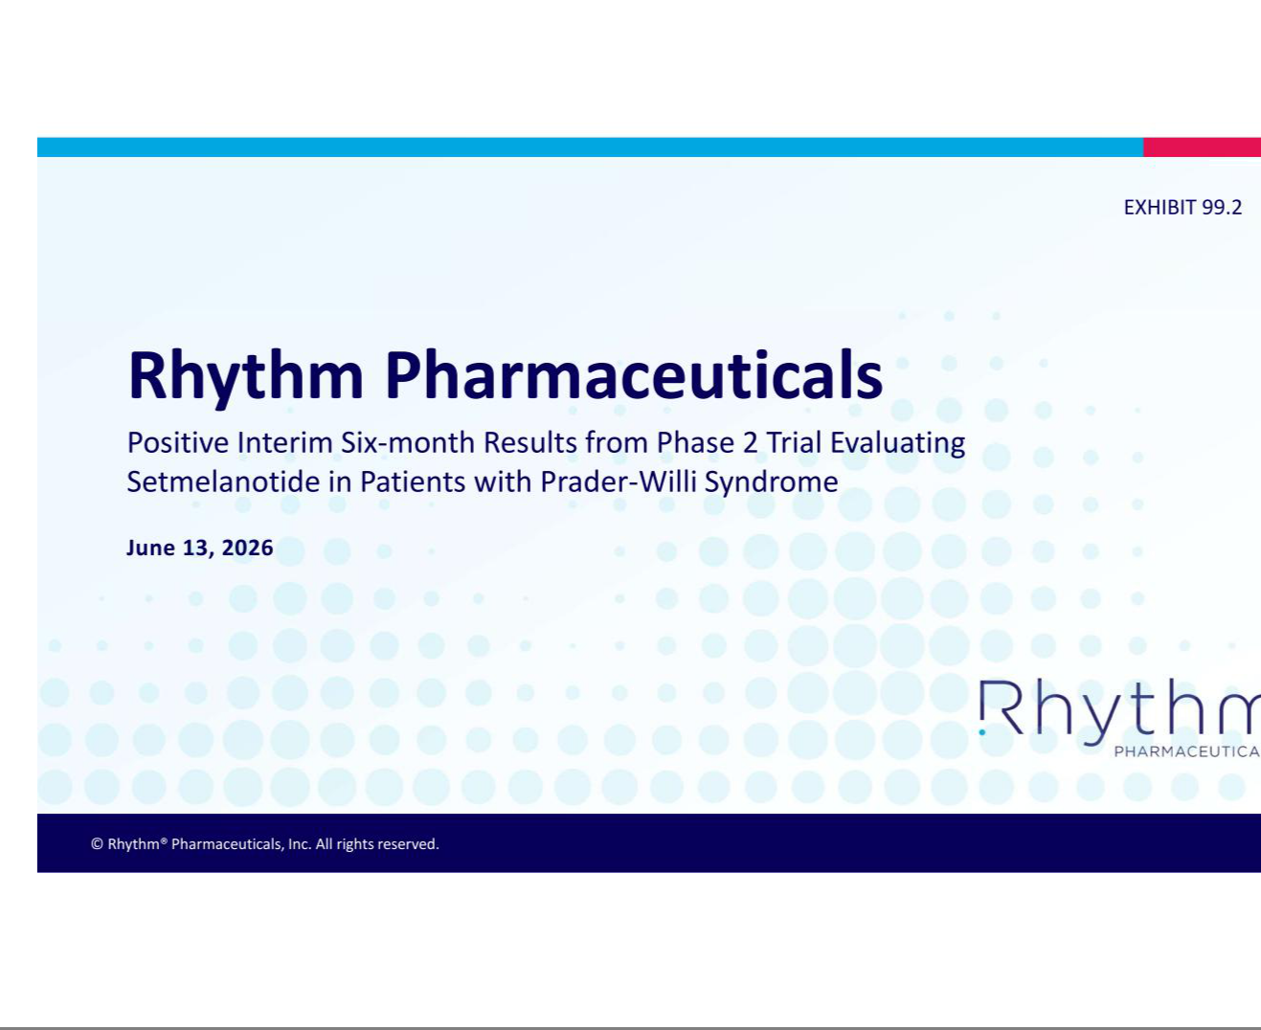

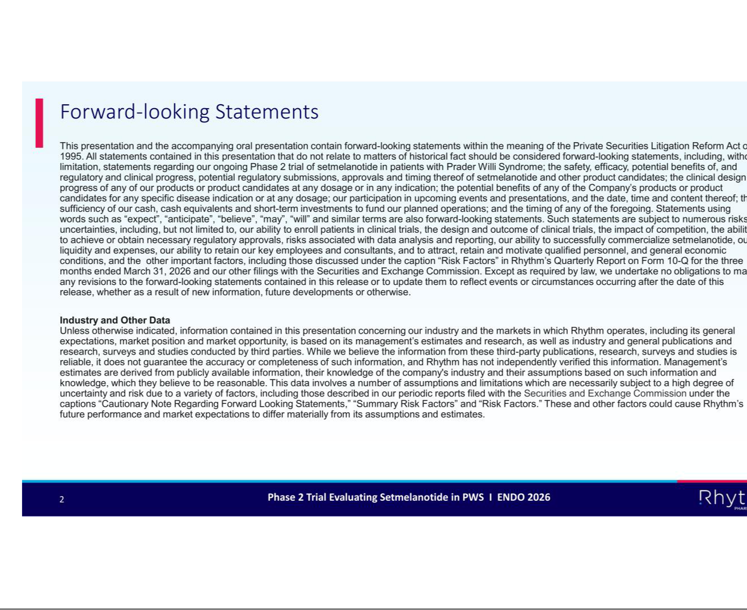





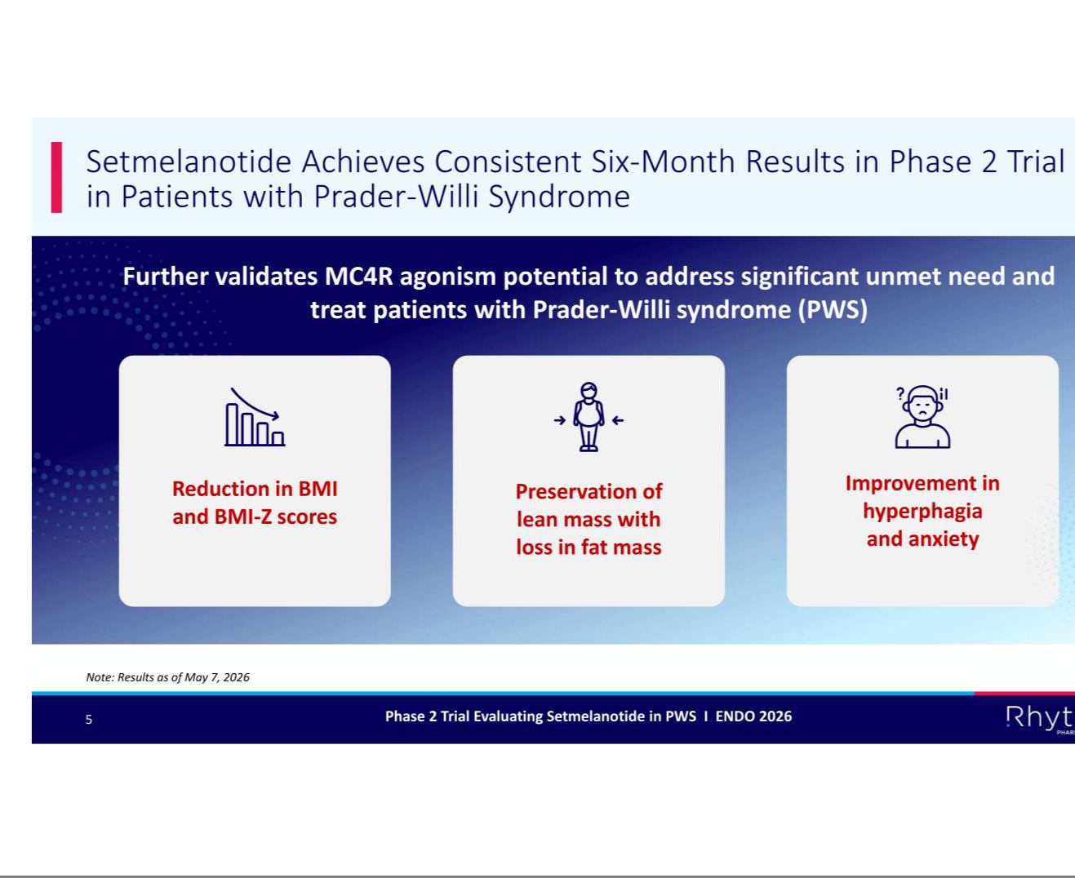

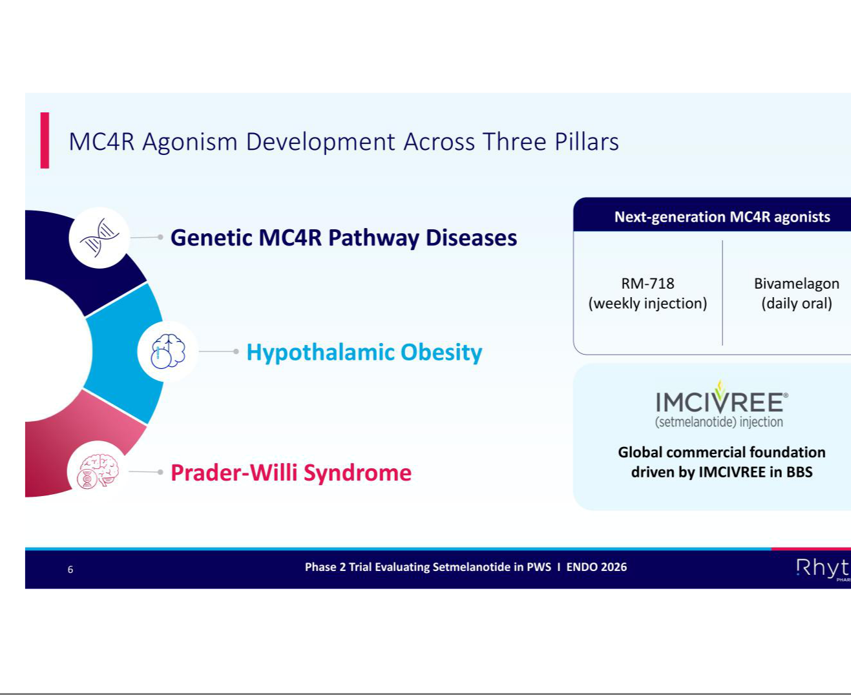

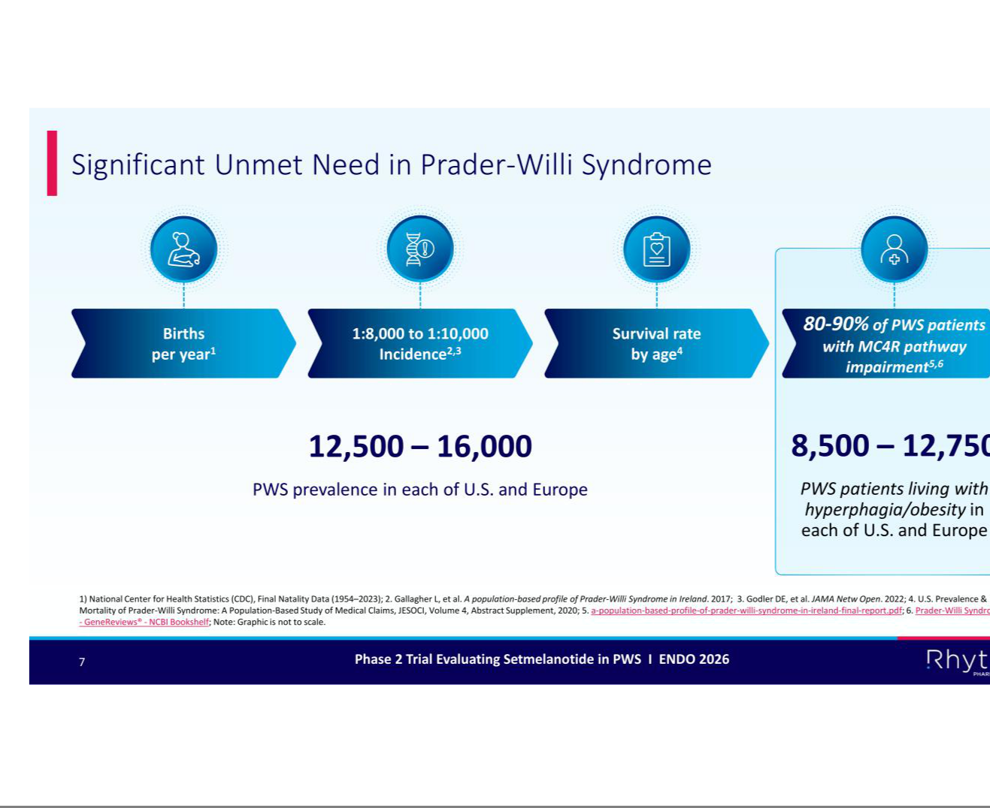

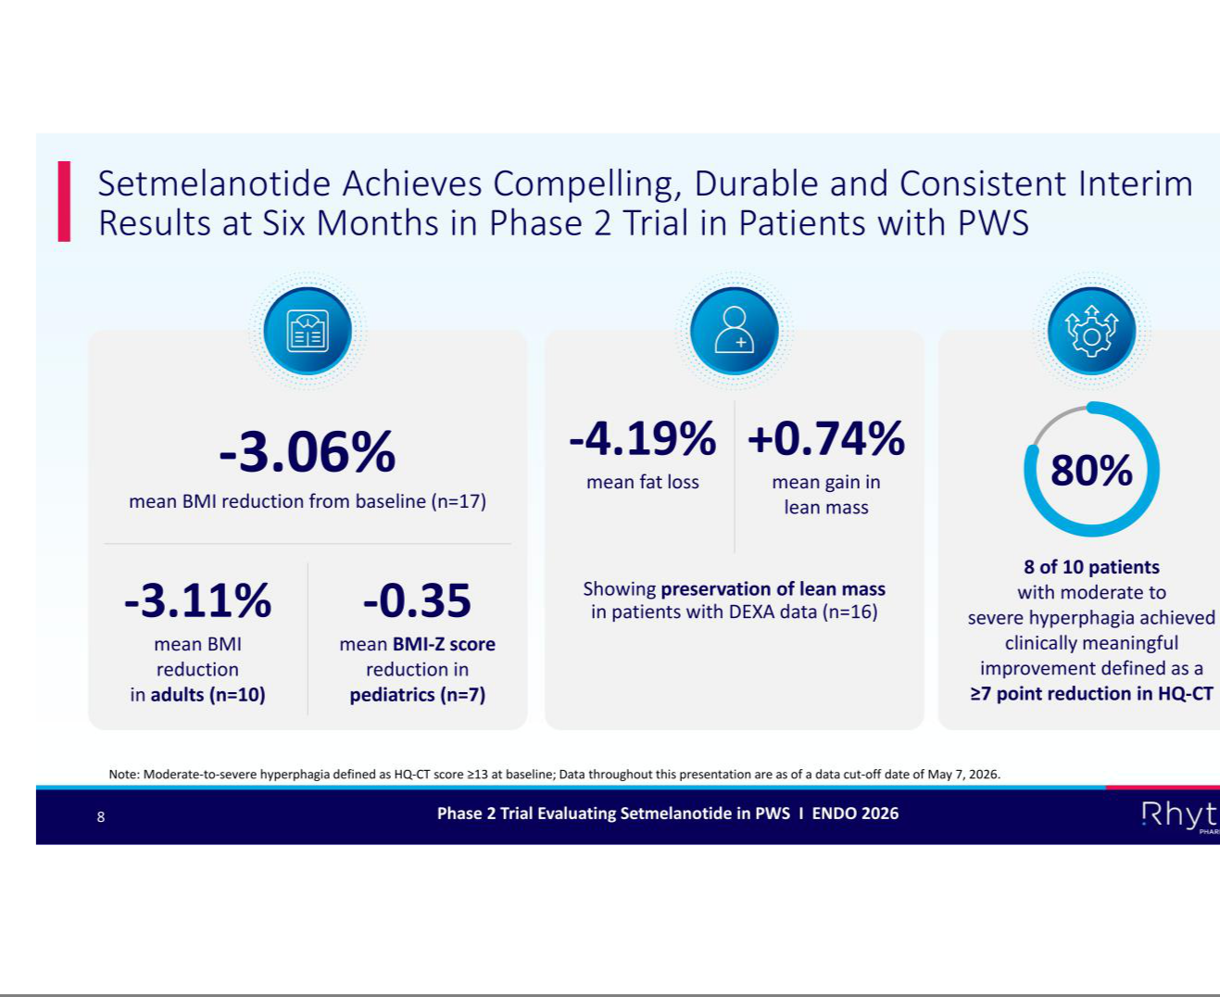

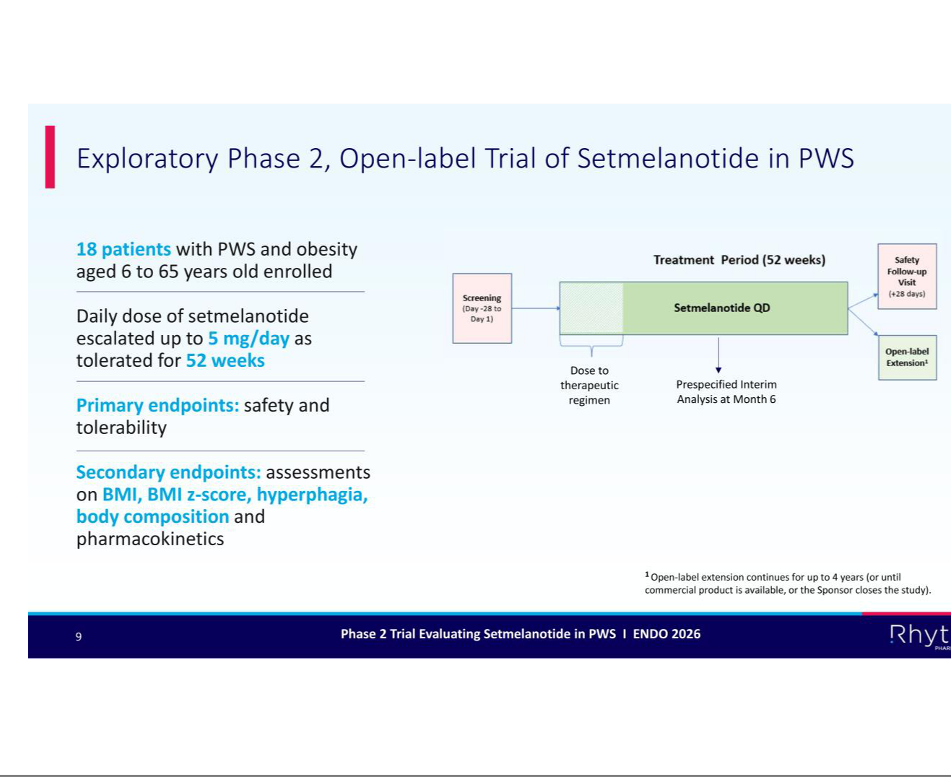

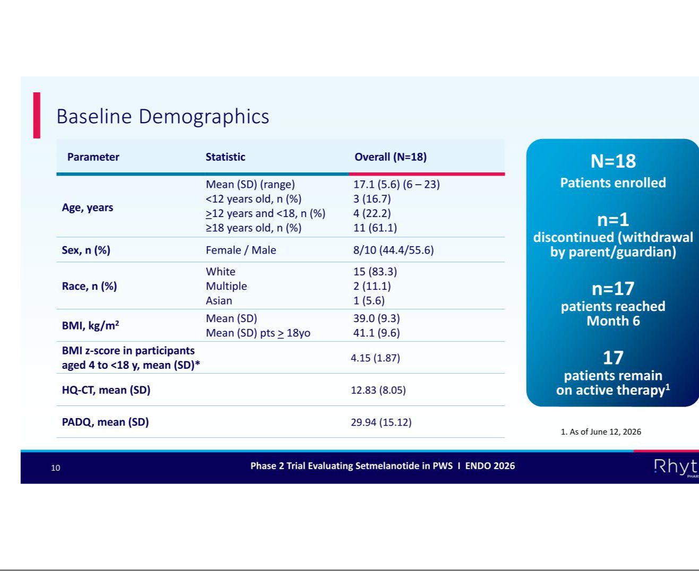

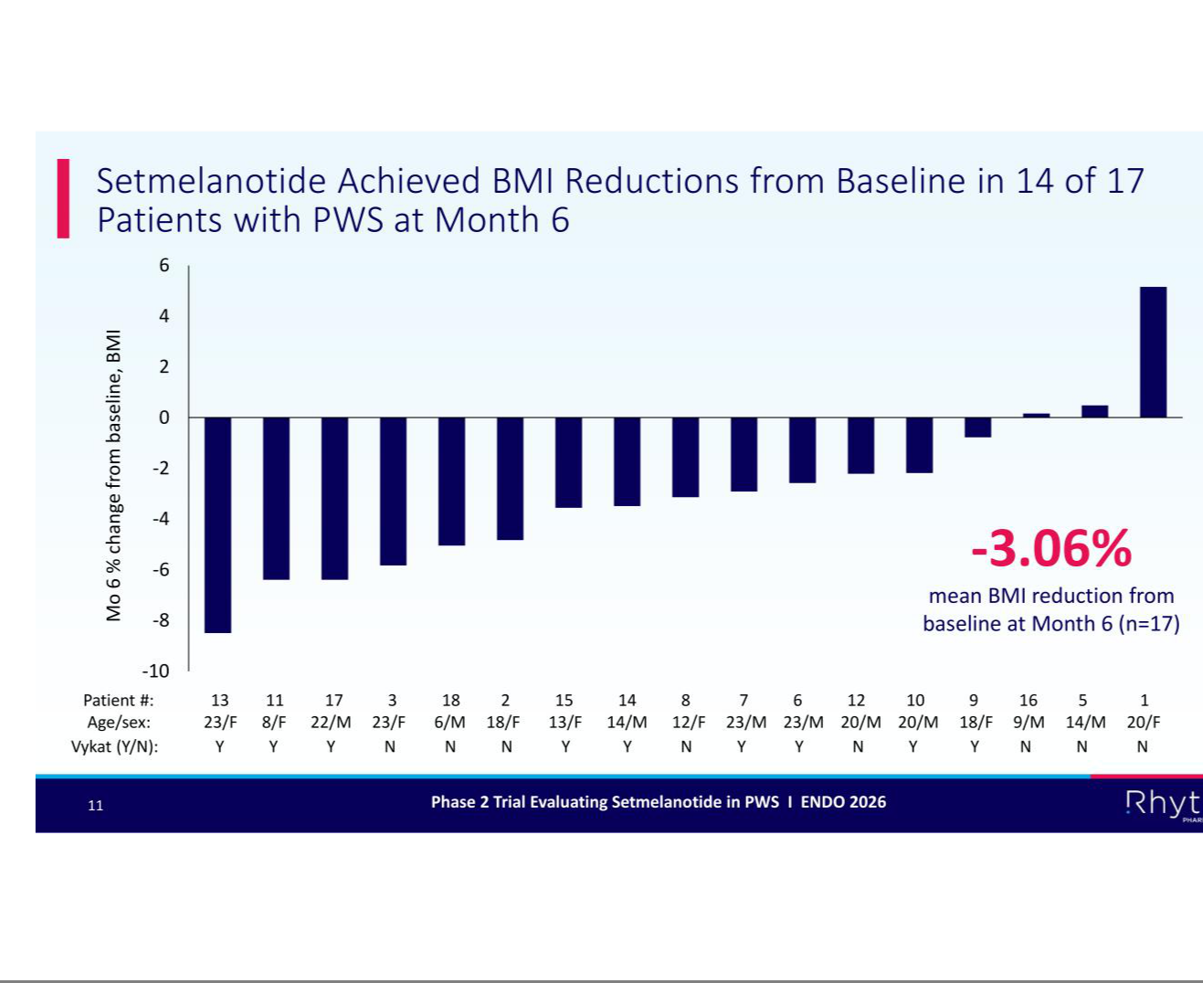

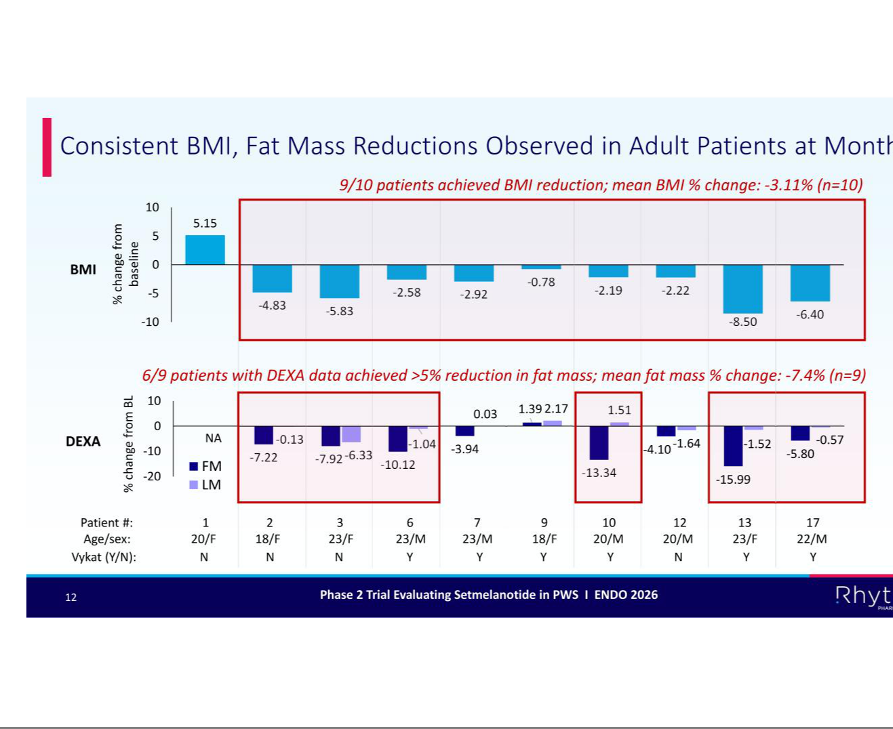

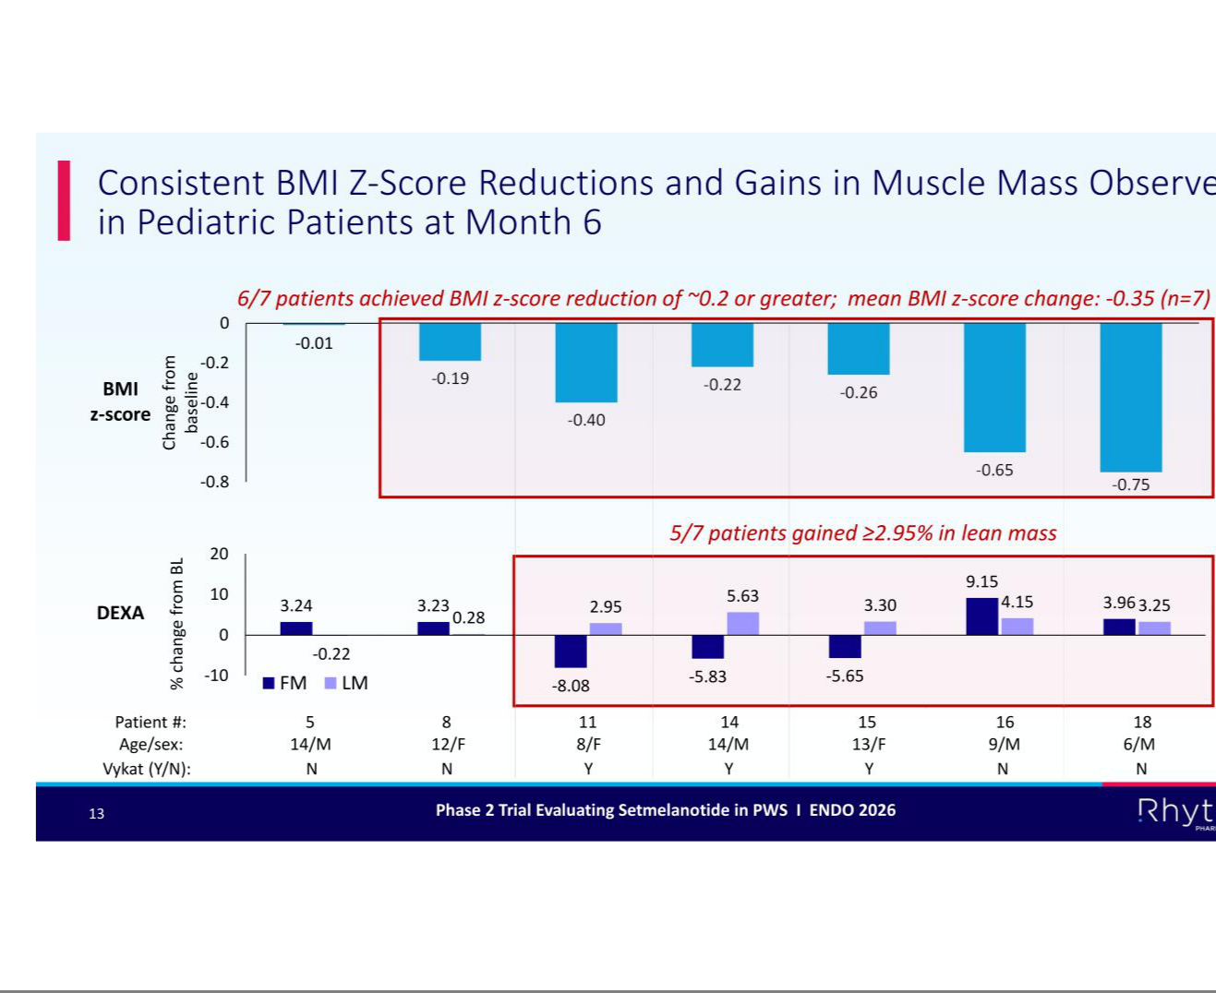

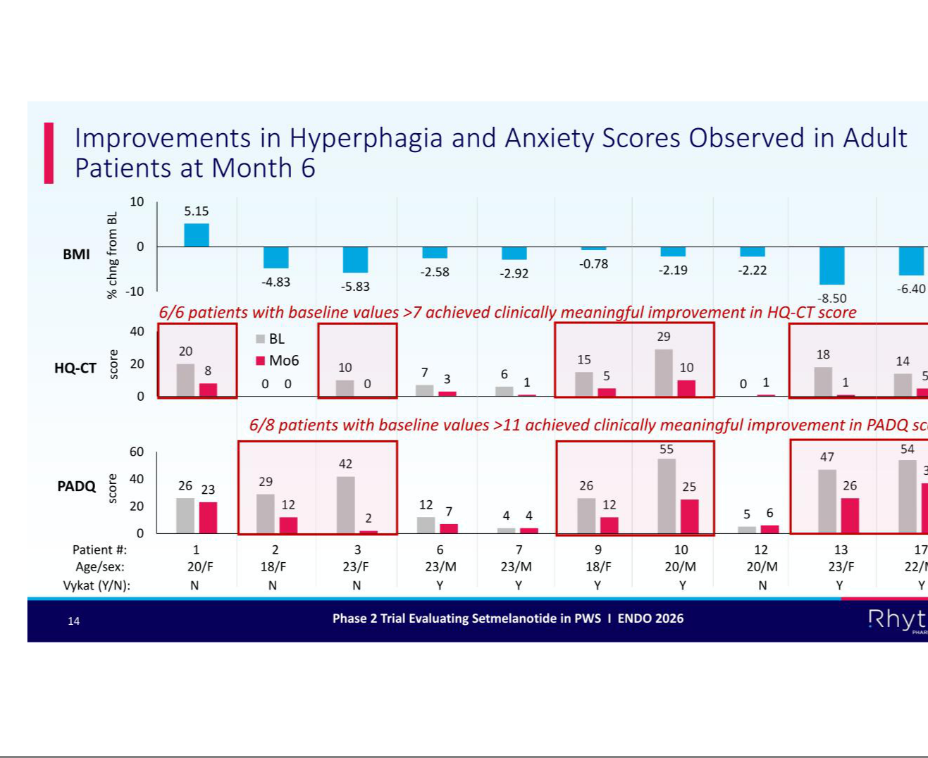

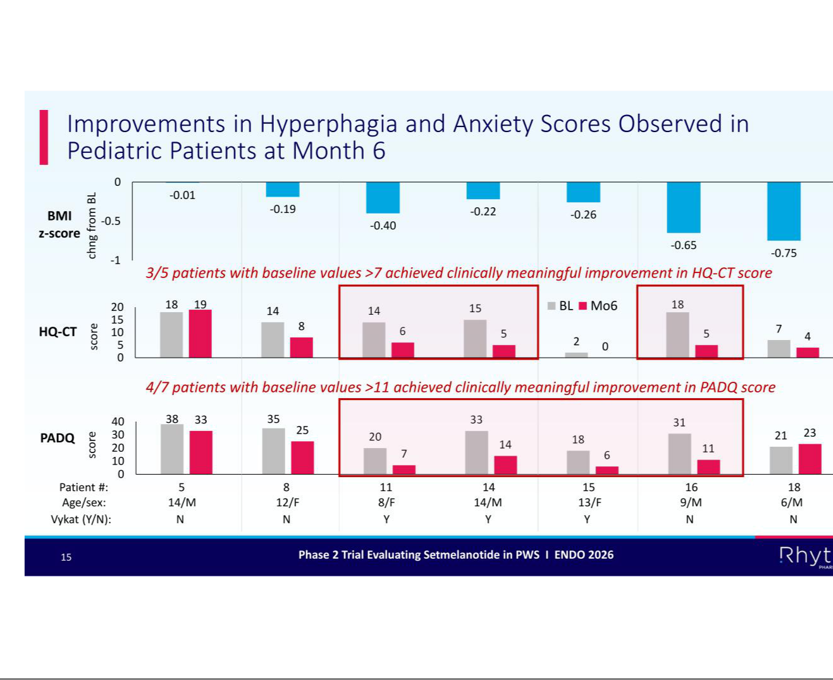

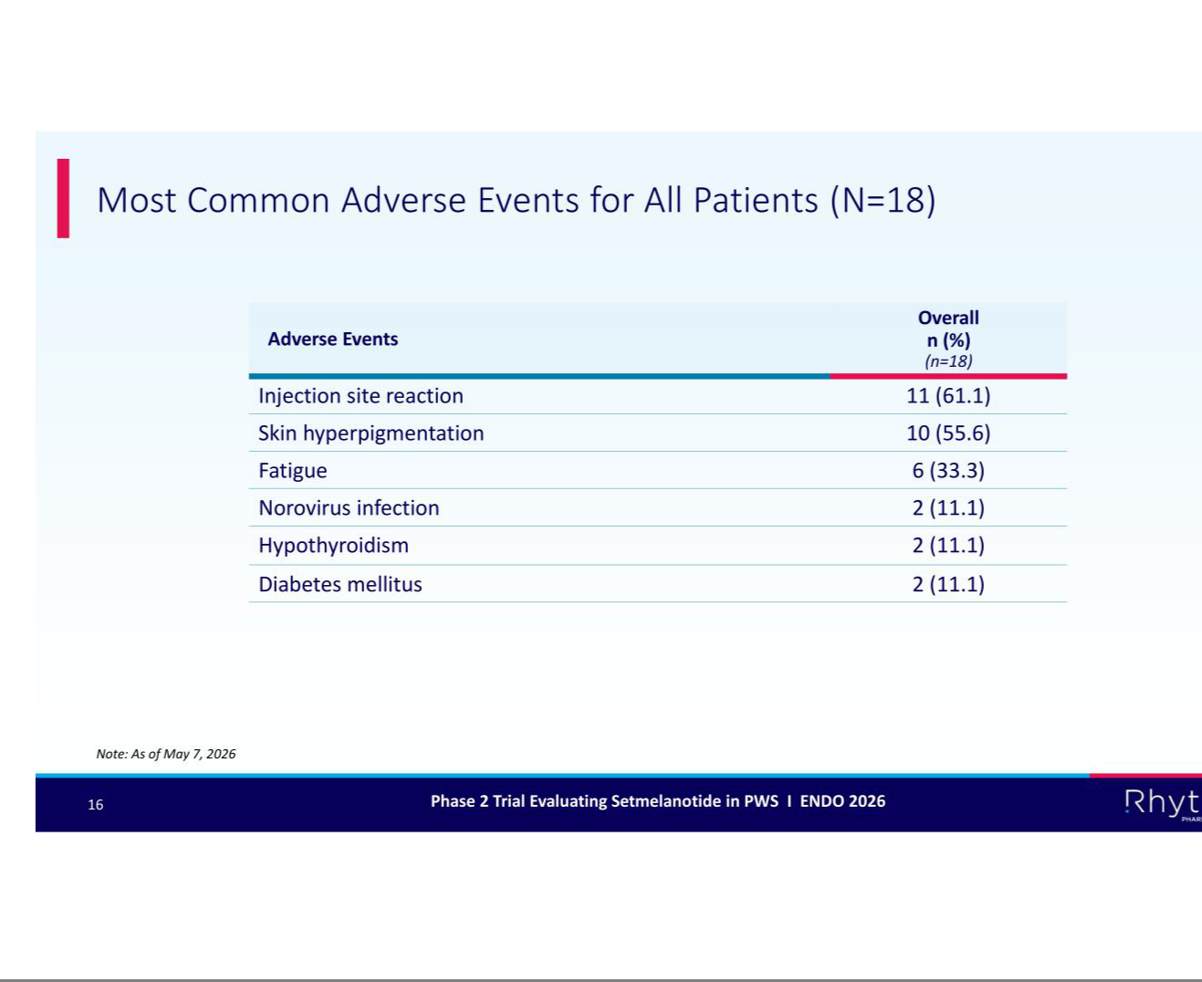



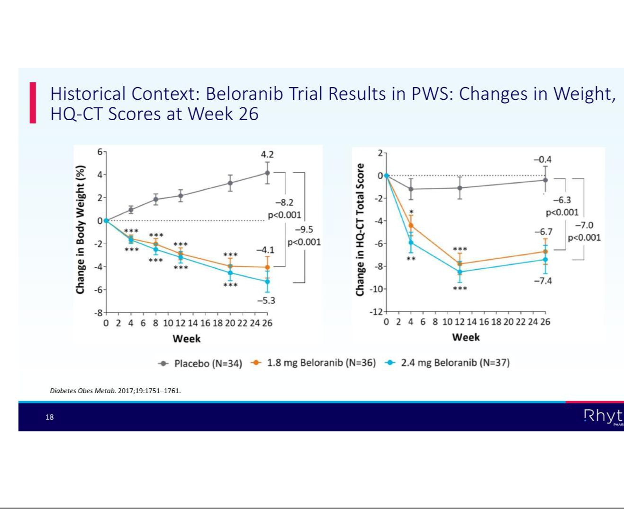





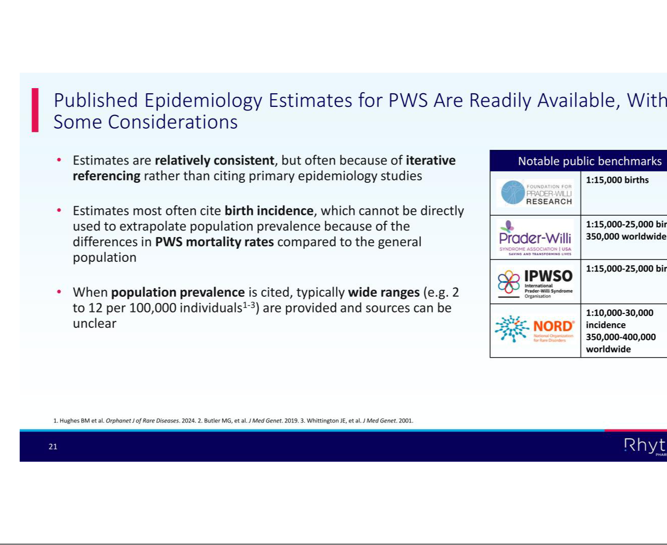

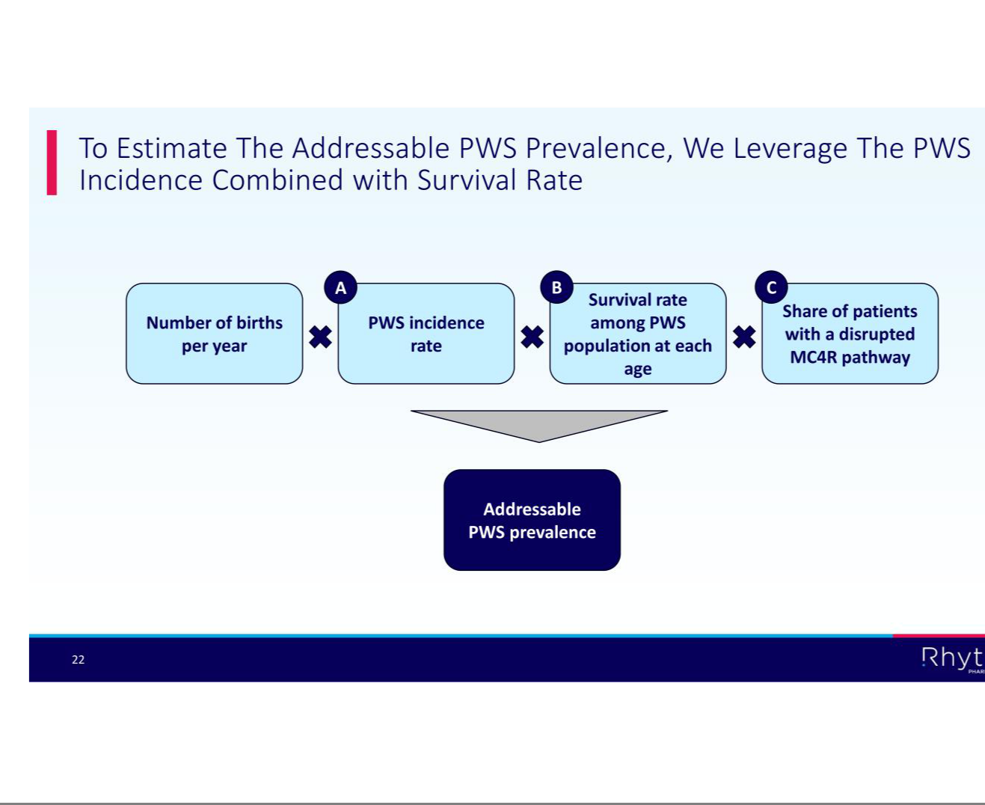

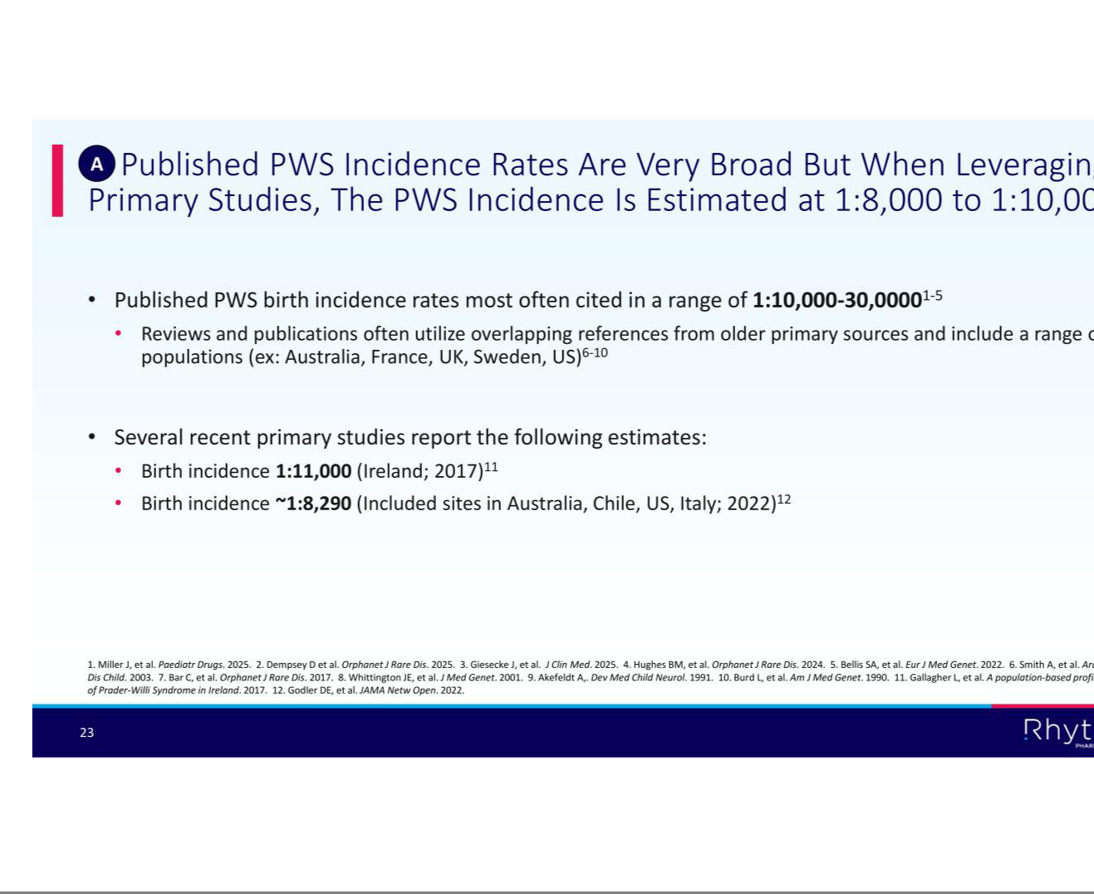

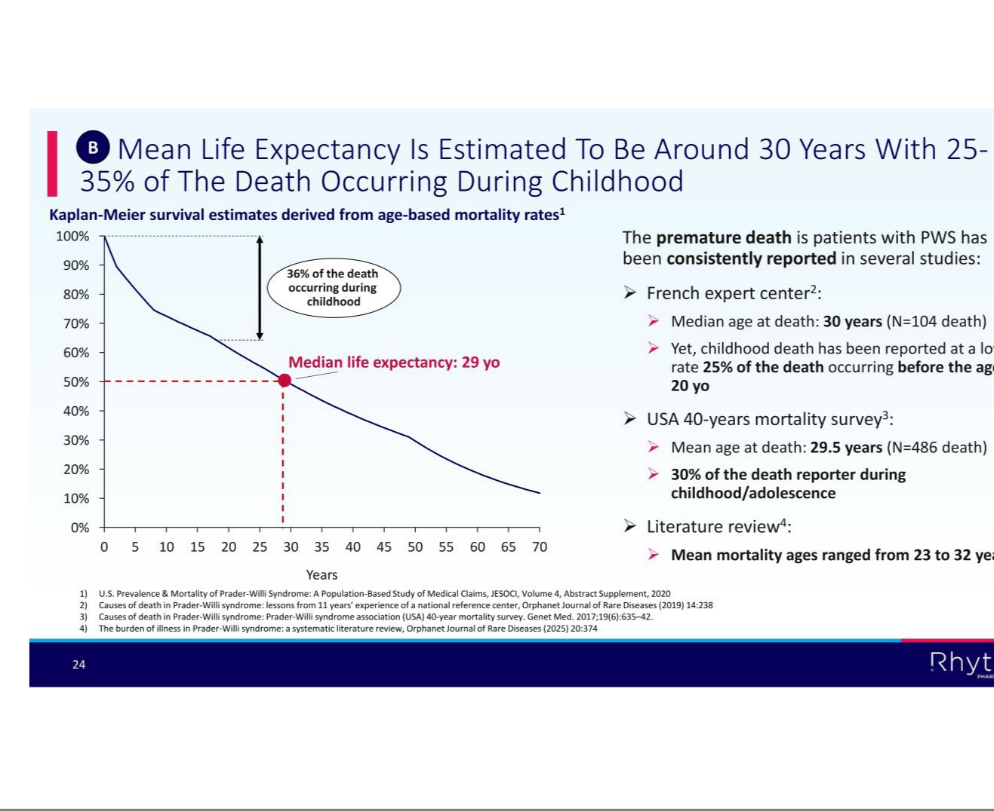

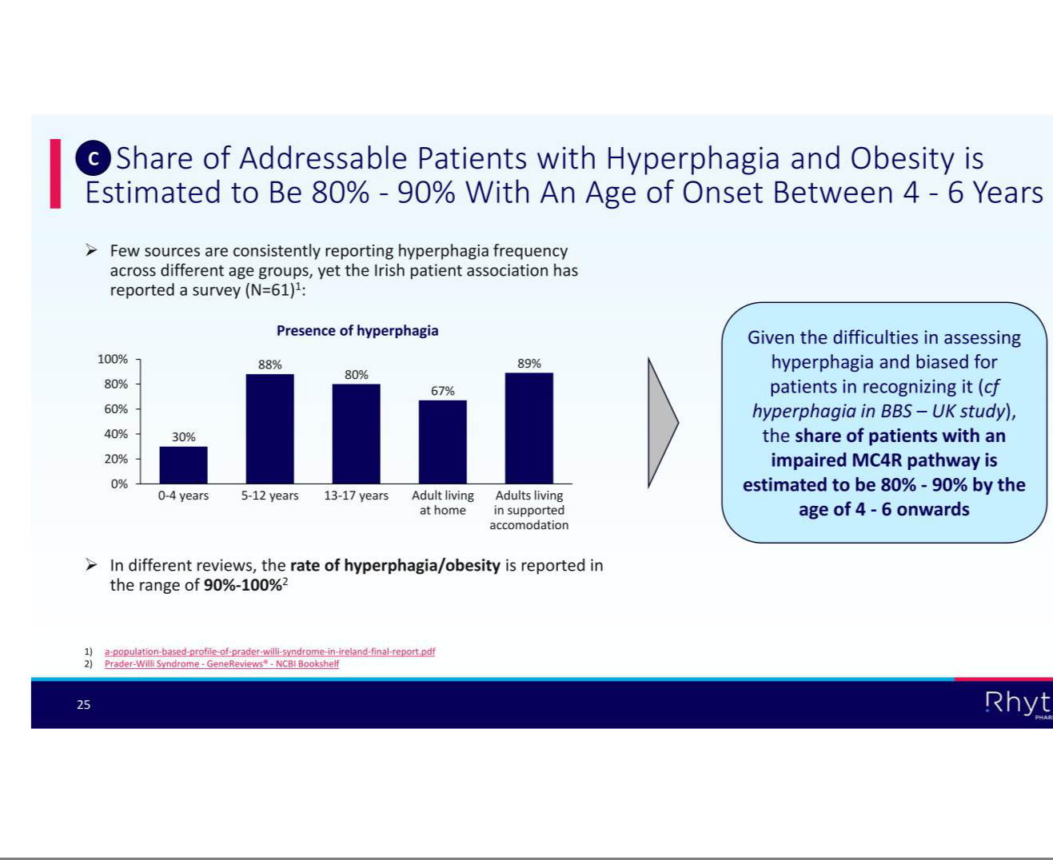

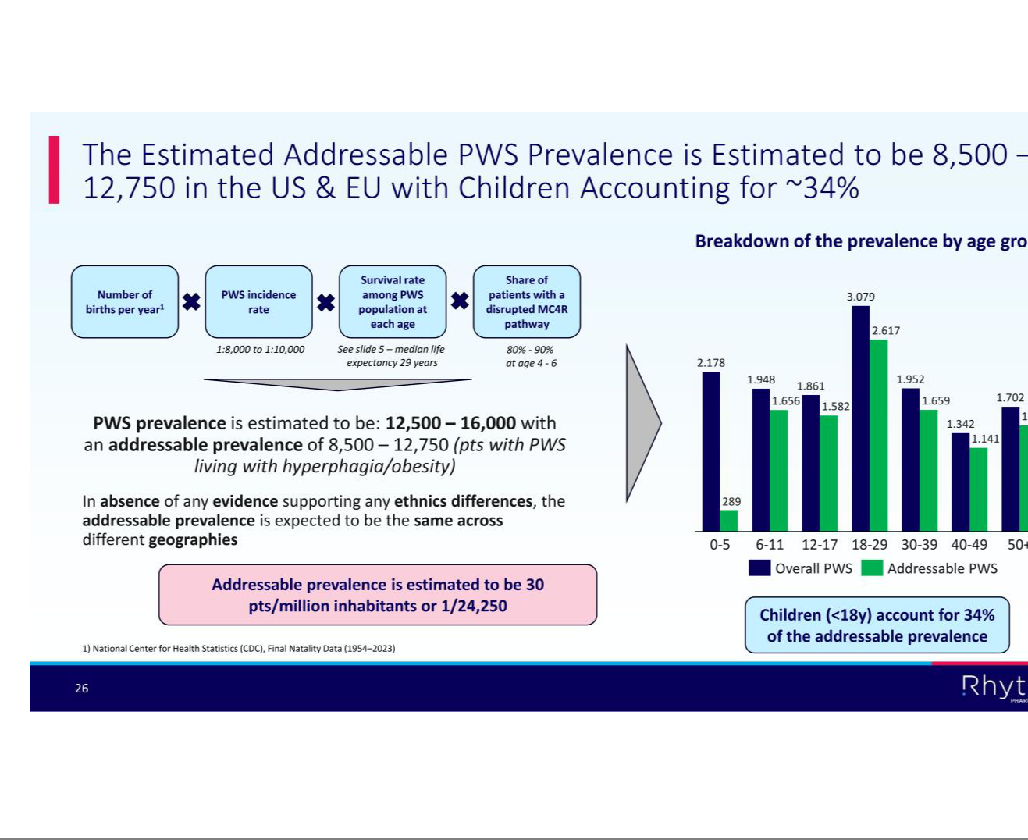

EXHIBIT 99.3

Rhythm Pharmaceuticals Announces Multiple New Data Presentations from MC4R Agonists in Acquired Hypothalamic Obesity (HO), Bardet-Biedl Syndrome (BBS) and Prader-Willi Syndrome (PWS) at ENDO 2026
-- Setmelanotide therapy achieved robust, sustained and clinically significant weight loss in patients with acquired HO at 2.5 years --

-- Bivamelagon therapy achieved progressive reductions in BMI and hunger measures in patients (N=26) with acquired HO at one year --

- Real-world data showed patients with BBS treated with setmelanotide (N=286) achieved improvements in weight-related outcomes, reduction in healthcare resource utilization

--

- Additional presentations highlight analyses of setmelanotide therapy in patients with acquired HO who achieved weight category improvements; BMI reductions after prior bariatric surgery in acquired HO patients treated with setmelanotide; and positive data following 6 months of treatment in patients with PWS --

BOSTON, June 15, 2026 – Rhythm Pharmaceuticals, Inc. (Nasdaq: RYTM), a global commercial-stage biopharmaceutical company focused on transforming the lives of patients living with rare neuroendocrine diseases, today announced new data from multiple presentations during the Endocrine Society’s Annual Meeting (ENDO 2026) in Chicago.

“Rare MC4R pathway diseases such as acquired hypothalamic obesity (HO), Bardet-Biedl syndrome (BBS) and Prader-Willi syndrome (PWS) are severe, chronic diseases with limited or no effective treatment options,” said Rhythm Chairman, CEO and President David Meeker, MD. “We are excited to share positive results across these diseases showing MC4R agonism continues to demonstrate its potential to meaningfully reduce hyperphagia and improve weight-related outcomes in these patients. ENDO provides an important platform to engage with the global endocrinology community, and we are focused on continuing to translate this science into treatments for patients with significant unmet need.”

Long-Term Efficacy with Setmelanotide in Patients with Acquired Hypothalamic Obesity

Presented as an oral presentation by Christian Roth, M.D., Seattle Children’s Research Institute, this analysis evaluated long-term efficacy and safety of setmelanotide therapy in patients with acquired HO for up to 2.5 years of treatment in a Phase 2 study and long-term extension. Key findings include:

- -18.9% mean BMI reduction across all participants (n=11);

- Mean change from baseline in BMI z-score was -1.60

- The most common adverse events were nausea, skin hyperpigmentation, upper respiratory tract infection, and vomiting.

Weight Reduction After 1 Year of Oral Bivamelagon in Acquired Hypothalamic Obesity

Presented as a poster by Dr. Vidhu Thaker, M.D., Pediatric Endocrinology, Columbia University, this analysis evaluated 1-year efficacy and safety results from a Phase 2 study of oral bivamelagon in patients with acquired HO, including 14 weeks of double-blind treatment followed by a 38-week open-label extension. Twenty-six of 28 patients who originally enrolled in this Phase 2 trial remained on therapy in the open-label extension and reached at least 52 weeks on therapy. The mean change in BMI from baseline to Week 52 for patients (n=26) was:

- −8.7% for patients who transitioned from placebo to 600 mg (n=7);

- −6.7% for patients who received 200 mg then 600 mg (n=6);

- −10.8% for patients who received 400 mg then 600 mg (n=6);

- −16.6% for patients who received 600 mg throughout (n=7);

- The mean change in the weekly average of the maximal daily hunger score ranged from −1.9 to −4.8 across cohorts;

- In pediatric patients (n=13), mean change in BMI z-score from baseline to Week 52 ranged from −0.22 to −0.69 across treatment groups; and

- Common adverse events reported were vomiting, nausea, diarrhea, and headache.

Setmelanotide Treatment in Patients with Acquired Hypothalamic Obesity and Previous Weight Loss Surgery

Presented as a poster by Ashley Shoemaker, M.D., MSCI, Senior Medical Director at Rhythm Pharmaceuticals, this analysis evaluated outcomes in patients with acquired HO who had a pre-trial history of bariatric surgery and were treated with setmelanotide or placebo in a Phase 3 trial. Key findings in this post-hoc analysis of patients who tried bariatric surgery and subsequently enrolled in a trial of setmelanotide therapy and completed the trial include:

- Patients treated with setmelanotide (n=3) achieved reductions in BMI at 1 year, with changes ranging from −9.6% to −37.9%, compared with a 4.8% increase in the placebo-treated patient (n=1);

- Patients had a history of multiple bariatric procedures, including gastric sleeve and gastric bypass, with persistent obesity prior to study entry despite prior surgical intervention; and

- Treatment-related adverse events were reported in one participant (upper abdominal pain, constipation, nausea, and headache) who received setmelanotide.

Weight Category Improvement Following Setmelanotide in Patients with Acquired Hypothalamic Obesity Presented as a poster by Ashley Shoemaker, M.D., MSCI, Senior Medical Director at

Rhythm Pharmaceuticals, this analysis evaluated changes in weight category after 1 year of treatment with setmelanotide in patients with acquired hypothalamic obesity from a

Phase 3 trial. Key findings include:

- Weight category improvements of one category or more were observed in 71.1% of pediatric patients (n=45) and 71.4% of adult patients (n=28) treated with setmelanotide vs. 13.6% (n=22) and 6.7% (n=15), respectively, with placebo;

- Weight category improvements of two categories or more were observed in 44.4% of pediatric patients (n=45) and 50.0% of adults (n=28) treated with setmelanotide, with no patients in the placebo group achieving ≥2 category improvement;

- After 1 year, 43.8% of patients treated with setmelanotide achieved either overweight or healthy weight status vs. 13.5% receiving placebo achieved overweight, with no placebo-treated patients achieving healthy weight status; and

- Common adverse events were skin hyperpigmentation, nausea, vomiting, and headache.

Real-World Weight and Healthcare Utilization Outcomes with Setmelanotide in U.S. Patients with Bardet-Biedl Syndrome

Presented as a poster by Caroline Huber, Director of Value & Evidence at Rhythm Pharmaceuticals, this retrospective analysis evaluated the real-world

effectiveness of setmelanotide on weight-related outcomes and healthcare resource utilization among U.S. patients (n= 286) with obesity due to BBS. Key findings include:

- After 12 months of setmelanotide treatment, 62% of adults achieved ≥10% body weight loss;

- -9.8% mean percent body weight loss in adults and -7.8% across all patients;

- There was a significant reduction in outpatient obesity-related visits following treatment initiation (rate difference: 1.03; p<0.05); and

- In a secondary analysis, patients who took the longest to initiate setmelanotide (n=163) weighed 20.8% more at treatment initiation and had 13.4% higher BMI vs earlier initiators

Transforming the Burden of Hyperphagia in Bardet-Biedl Syndrome: 6-Month Real-World Outcomes for the RESTORE Study

Presented as a poster by Caroline Huber, Director of Value & Evidence at Rhythm Pharmaceuticals, this interim analysis from the real-world RESTORE study evaluated patient-and caregiver-reported outcomes in individuals with BBS treated with setmelanotide over six months (n=22). Key findings include:

- 90.9% reported prevalence of hyperphagia, assessed via self-/caregiver-report;

- Self-reporting participants with hyperphagia (n=17) experienced rapid and sustained reductions in hyperphagia symptoms/behaviors;

- Among participant-reported outcomes, mean Symptoms of Hyperphagia (SoH) scores from baseline decreased by −0.6 at month 1 and −0.5 at month 6;

- Mean Impacts of Hyperphagia (IoH) scores from baseline decreased by −1.2 at month 1 and −1.3 at month 6;

- After six months of setmelanotide treatment, 93% of participants reported no “waking up during the night from hunger” and “eating dropped/discarded food”;

- The most improved symptoms/behaviors in patients treated with setmelanotide were “feeling hungry after just eating” and “hiding what/how much you were eating;” and

- After six months of treatment, use of other anti-obesity medications decreased by 25%, and participants reported positive lifestyle changes, including smaller portion sizes, and increased time spent exercising.

On Saturday, June 13, the Company announced six-month results from the Phase 2 trial evaluating setmelanotide in patients with Prader-Willi syndrome (PWS). The presentations from ENDO 2026 are available at: https://hcp.rhythmtx.com/publications-presentations/

About Rhythm Pharmaceuticals

Rhythm is a commercial-stage biopharmaceutical company committed to transforming the lives of patients and their families living with rare neuroendocrine diseases. Rhythm’s lead asset, IMCIVREE® (setmelanotide), an MC4R agonist designed to treat hyperphagia and severe obesity, is approved by the U.S. Food and Drug Administration (FDA) to reduce excess body weight and maintain weight reduction long term in adult and pediatric patients aged 4 years and older with acquired hypothalamic obesity, adult and pediatric patients 2 years of age and older with syndromic or monogenic obesity due to Bardet-Biedl syndrome (BBS) or genetically confirmed pro-opiomelanocortin (POMC), including proprotein convertase subtilisin/kexin type 1 (PCSK1), deficiency or leptin receptor (LEPR) deficiency. The European Commission (EC) has authorized setmelanotide for the treatment of obesity and control of hunger in patients 4 years of age and above with acquired hypothalamic obesity; and both the EC and the UK’s Medicines & Healthcare Products Regulatory Agency (MHRA) have authorized setmelanotide for the treatment of obesity and the control of hunger associated with genetically confirmed BBS or genetically confirmed loss-of-function biallelic POMC, including PCSK1, deficiency or biallelic LEPR deficiency in adults and children 2 years of age and above. Additionally, Rhythm is advancing a broad clinical development program for setmelanotide in other rare diseases, as well as investigational MC4R agonists bivamelagon and RM-718, and a preclinical suite of small molecules for the treatment of congenital hyperinsulinism. Rhythm’s headquarters is in Boston, MA.

Setmelanotide Indication

In the United States, setmelanotide is indicated to reduce excess body weight and maintain weight reduction long term in adults and pediatric patients aged 4 years and older with acquired hypothalamic obesity, in adult and pediatric patients aged 2 years and older with syndromic or monogenic obesity due to Bardet-Biedl syndrome (BBS) or Pro-opiomelanocortin (POMC), proprotein convertase subtilisin/kexin type 1 (PCSK1), or leptin receptor (LEPR) deficiency confirmed by genetic testing demonstrating variants in POMC, PCSK1, or LEPR genes that are interpreted as pathogenic, likely pathogenic, or of uncertain significance (VUS).

In the European Union and the United Kingdom, setmelanotide is indicated for the treatment of obesity and the control of hunger associated with genetically confirmed BBS or loss-of-function biallelic POMC, including PCSK1, deficiency or biallelic LEPR deficiency in adults and children 2 years of age and above. In the European Union and the United Kingdom, setmelanotide should be prescribed and supervised by a physician with expertise in obesity with underlying genetic etiology.

Limitations of Use

Setmelanotide is not indicated for the treatment of patients with the following conditions as setmelanotide would not be expected to be effective:

- Obesity due to suspected POMC, PCSK1, or LEPR deficiency with POMC, PCSK1, or LEPR variants classified as benign or likely benign

- Other types of obesity not related to acquired HO, BBS, or POMC, PCSK1 or LEPR deficiency, including obesity associated with other genetic syndromes and general (polygenic) obesity.

Important Safety Information

CONTRAINDICATIONS

Prior serious hypersensitivity to setmelanotide or any of the excipients in IMCIVREE. Serious hypersensitivity reactions (e.g., anaphylaxis) have been reported.

WARNINGS AND PRECAUTIONS

Disturbance in Sexual Arousal: Spontaneous penile erections and increased frequency of penile erections in males have occurred. Inform patients that these events may occur and instruct patients who have an erection lasting longer than 4 hours to seek emergency medical attention.

Depression and Suicidal Ideation: Depression and suicidal ideation have occurred. Monitor patients for new onset or worsening depression or suicidal thoughts or behaviors.

Consider discontinuing IMCIVREE if patients experience suicidal thoughts or behaviors, or clinically significant or persistent depression symptoms occur.

Hypersensitivity Reactions: Serious hypersensitivity reactions (e.g., anaphylaxis) have been reported. If suspected, advise patients to promptly seek medical attention and discontinue IMCIVREE.

Skin Hyperpigmentation, Darkening of Pre-existing Nevi, and Development of New Melanocytic Nevi: Generalized or focal increases in skin pigmentation occurred in the majority of IMCIVREE-treated patients. IMCIVREE may also cause development of new melanocytic nevi or darkening of pre-existing nevi. Perform a full body skin examination prior to initiation and periodically during treatment to monitor pre-existing and new pigmented lesions.

Acute Adrenal Insufficiency with Acquired HO: Patients with acquired HO and secondary adrenal insufficiency reported serious adverse reactions related to acute adrenal insufficiency in 5% of IMCIVREE-treated patients and no placebo-treated patients. In patients with secondary adrenal insufficiency, monitor for clinical signs of acute adrenal insufficiency.

Sodium Imbalance in Patients with Acquired HO and Central Diabetes Insipidus: Patients with acquired HO and concomitant central diabetes insipidus (DI)/arginine vasopressin (AVP) deficiency reported hyponatremia in 6% of IMCIVREE-treated patients and 2% of placebo-treated patients and hypernatremia in 5% of IMCIVREE-treated patients and 4% of placebo-treated patients. Monitor serum sodium levels with changes in fluid intake and hydration status. Adjust the doses of concomitant therapies for DI/AVP deficiency as needed.

ADVERSE REACTIONS

Most common adverse reactions (incidence ≥20% in at least 1 indication) included skin hyperpigmentation, injection site reactions, nausea, headache, diarrhea, abdominal pain, vomiting, depression, and spontaneous penile erection.

USE IN SPECIFIC POPULATIONS

Treatment with IMCIVREE is not recommended when breastfeeding. Discontinue IMCIVREE when pregnancy is recognized unless the benefits of therapy outweigh the potential risks to the fetus.

To report SUSPECTED ADVERSE REACTIONS, contact Rhythm Pharmaceuticals at +1 (833) 789-6337 or FDA at 1-800-FDA-1088 or http://www.fda.gov/medwatch. See section 4.8 of the Summary of Product Characteristics for information on reporting suspected adverse reactions in Europe.

Please see the full Prescribing Information for additional Important Safety Information.

Forward-looking Statements

This press release contains forward-looking statements within the meaning of the Private Securities Litigation Reform Act of 1995. All statements contained in this press release that do not relate to matters of historical fact should be considered forward-looking statements, including, without limitation, statements regarding the safety, efficacy, potential benefits of, and clinical design or progress, potential regulatory submissions, approvals and timing thereof for any of our products or product candidates at any dosage or in any indication; the presentation of clinical data and results from our trials, including the ongoing Phase 2 trial of setmelanotide in patients with PWS, clinical and real-world efficacy and safety data related to the use of setmelanotide and any of our other product candidates in patients with acquired hypothalamic obesity and our participation in upcoming events and presentations, and the content, date and timing of any of the foregoing. Statements using words such as “expect”, “anticipate”, “believe”, “may”, “will” and similar terms are also forward-looking statements. Such statements are subject to numerous risks and uncertainties, including, but not limited to, our ability to enroll patients in clinical trials, the design and outcome of clinical trials, the impact of competition, the ability to achieve or obtain necessary regulatory approvals, risks associated with data analysis and reporting, unfavorable pricing regulations, third-party reimbursement practices or healthcare reform initiatives, risks associated with the laws and regulations governing our international operations and the costs of any related compliance programs, our ability to successfully commercialize setmelanotide, our liquidity and expenses, our ability to retain our key employees and consultants, and to attract, retain and motivate qualified personnel, and general economic conditions, and other important factors, including those discussed under the caption “Risk Factors” in Rhythm’s Quarterly Report on Form 10-Q for the three months ended March 31, 2026, and our other filings with the Securities and Exchange Commission. Except as required by law, we undertake no obligations to make any revisions to the forward-looking statements contained in this release or to update them to reflect events or circumstances occurring after the date of this release, whether as a result of new information, future developments or otherwise.

# # #

Corporate Contacts:

David Connolly

Head of Investor Relations and Corporate Communications

Rhythm Pharmaceuticals, Inc.

857-264-4280

dconnolly@rhythmtx.com

Kate Walsh

Director, Corporate Communications

Rhythm Pharmaceuticals, Inc.

- 264-4280 kwalsh@rhythmtx.com

