UNITED STATES
SECURITIES AND EXCHANGE COMMISSION
Washington, D.C. 20549
FORM 8-K
CURRENT REPORT
Pursuant to Section 13 or 15(d)
of the Securities Exchange Act of 1934
Date of Report (Date of earliest event reported): August 4, 2026
RHYTHM PHARMACEUTICALS, INC.
(Exact name of registrant as specified in its charter)
Delaware |  |  | 001-38223 |  |  | 46-2159271
(State or other jurisdiction  of incorporation) |  |  | (Commission  File Number) |  |  | (IRS Employer  Identification Number)
222 Berkeley Street
12th Floor
Boston, MA 02116
(Address of principal executive offices) (Zip Code)
Registrant’s telephone number, including area code: (857) 264-4280
N/A
(Former name or former address, if changed since last report)
Check the appropriate box below if the Form 8-K filing is intended to simultaneously satisfy the filing obligation of the registrant under any of the following provisions:
☐ Written communications pursuant to Rule 425 under the Securities Act (17 CFR 230.425)
☐ Soliciting material pursuant to Rule 14a-12 under the Exchange Act (17 CFR 240.14a-12)
☐ Pre-commencement communications pursuant to Rule 14d-2(b) under the Exchange Act (17 CFR 240.14d-2(b))
☐ Pre-commencement communications pursuant to Rule 13e-4(c) under the Exchange Act (17 CFR 240.13e-4(c))
Securities registered pursuant to Section 12(b) of the Act:
Title of each class |  |  | Trading  Symbol(s) |  |  | Name of each exchange on which registered
Common Stock, $0.001 par value per share |  |  | RYTM |  |  | The Nasdaq Stock Market LLC (Nasdaq Global Market)
Indicate by check mark whether the registrant is an emerging growth company as defined in Rule 405 of the Securities Act of 1933 (§230.405 of this chapter) or Rule 12b-2 of the Securities Exchange Act of 1934 (§240.12b-2 of this chapter).
Emerging growth company ☐
If an emerging growth company, indicate by check mark if the registrant has elected not to use the extended transition period for complying with any new or revised financial accounting standards provided pursuant to Section 13(a) of the Exchange Act. ☐

Item 2.02. Results of Operations and Financial Condition.
On August 4, 2026, Rhythm Pharmaceuticals, Inc. (the “Company”) announced its financial results for the second quarter ended June 30, 2026. The full text of the press release issued by the Company in connection with the announcement is furnished as Exhibit 99.1 to this Current Report on Form 8-K (the “Current Report”).
The information contained in Item 2.02 of this Current Report (including Exhibit 99.1 attached hereto) shall not be deemed “filed” for purposes of Section 18 of the Securities Exchange Act of 1934, as amended (the “Exchange Act”), or otherwise subject to the liabilities of that section, nor shall it be deemed incorporated by reference in any filing under the Securities Act of 1933, as amended (the “Securities Act”), or the Exchange Act, except as expressly provided by specific reference in such a filing.

Item 7.01. Regulation FD Disclosure.
On August 4, 2026, the Company also issued a press release and published a presentation announcing preliminary data from its ongoing Phase 2 trial evaluating RM-718 in patients with acquired hypothalamic obesity (HO), which are summarized under Item 8.01 below. The presentation is available in the “Events and Presentations” portion of the Company’s website at ir.rhythmtx.com. A copy of the press release and presentation are furnished as Exhibits 99.2 and 99.3, respectively, to this Current Report on Form 8-K
The information contained in Item 7.01 of this Current Report on Form 8-K (including Exhibits 99.1, 99.2 and 99.3 attached hereto) shall not be deemed “filed” for purposes of Section 18 of the Securities Exchange Act of 1934, as amended (the “Exchange Act”), or otherwise subject to the liabilities of that section, nor shall it be deemed incorporated by reference in any filing under the Securities Act of 1933, as amended (the “Securities Act”), or the Exchange Act, except as expressly provided by specific reference in such a filing.

Item 8.01. Other Events.
On August 4, 2026, the Company announced preliminary data from its ongoing Phase 2 trial evaluating RM-718 in patients with acquired hypothalamic obesity (HO), which are summarized below.
Eleven patients with acquired HO were enrolled in the ongoing, open-label trial. Key preliminary findings include:
• -11.6% reduction in mean BMI from baseline (n=7) at 16 weeks of RM-718;
• RM-718 efficacy results at 16 weeks comparable to mean BMI reduction of -10.1% with bivamelagon (600 mg dose; n=7) at 14 weeks and -10.1% BMI reduction with setmelanotide at 16 weeks (n=64 patients in Phase 2 and 3 trials); and
• Two (2) mild instances of hyperpigmentation were reported and were limited to the injection site, with no generalized hyperpigmentation observed.

RM-718 was generally well tolerated, with the most common adverse events being injection site reactions, nausea, and vomiting.

Eight (8) patients remained on active treatment as of July 16, 2026, including two (2) patients who had not yet reached 16 weeks on therapy. Two participants discontinued treatment due to adverse events: injection site induration and nausea. One patient withdrew from the extension portion of the trial.

Forward-Looking Statements

This Current Report on Form 8-K contains forward-looking statements within the meaning of the Private Securities Litigation Reform Act of 1995. All statements contained in this press release that do not relate to matters of historical fact should be considered forward-looking statements, including, without limitation, statements regarding the safety, efficacy, potential benefits of, and clinical design or progress of any of our products or product candidates at any dosage or in any indication, including, setmelanotide, bivamelagon, and RM-718; the use of setmelanotide in patients with acquired HO and the success of our commercial launch; our expectations surrounding potential regulatory submissions, progress, or approvals and timing thereof for any of our product candidates, including potential marketing approval and launch in Japan and launches in the European Union and the timing thereof; the commercial growth of IMCIVREE; the estimated market size and addressable population for our drug products, including setmelanotide for the treatment of acquired HO; the future

announcement of data from our ongoing clinical trials, including the substudy evaluating setmelanotide for patients with congenital hypothalamic obesity, Part C and Part D of the Phase 1 trial evaluating RM-718, and the open-label Phase 2 trial evaluating setmelanotide in patients with PWS, and ongoing enrollment in our clinical trials; existing or future collaboration agreements; the Company’s business strategy and plans; our anticipated financial performance and financial position for any period of time, including our estimated Non-GAAP Operating Expenses for the year ending December 31, 2026; and the sufficiency of our cash, cash equivalents and short-term investments to fund our operations for at least 24 months; and the timing of any of the foregoing. Statements using words such as “expect”, “anticipate”, “believe”, “may”, “will” and similar terms are also forward-looking statements. Such statements are subject to numerous risks and uncertainties, including, but not limited to, our ability to enroll patients in clinical trials, the design and outcome of clinical trials, the impact of competition, the ability to achieve or obtain necessary regulatory approvals, risks associated with data analysis and reporting, unfavorable pricing regulations, third-party reimbursement practices or healthcare reform initiatives, risks associated with the laws and regulations governing our international operations and the costs of any related compliance programs, our ability to successfully commercialize setmelanotide, our liquidity and expenses, our ability to retain our key employees and consultants, and to attract, retain and motivate qualified personnel, and general economic conditions, and the other important factors, including those discussed under the caption “Risk Factors” in Rhythm’s Quarterly Report on Form 10-Q for the quarter ended June 30, 2026 and our other filings with the Securities and Exchange Commission. Except as required by law, we undertake no obligations to make any revisions to the forward-looking statements contained in this press release or to update them to reflect events or circumstances occurring after the date of this press release, whether as a result of new information, future developments or otherwise.

Item 9.01. Financial Statements and Exhibits.
(d) Exhibits
The following Exhibit 99.1 relates to Item 2.02 and shall be deemed to be furnished, and not filed:
Exhibit  No. |  |  |  |  |  | Description
99.1 |  |  |  |  |  | Press Release dated August 4, 2026
99.2 |  |  |  |  |  | Press Release dated August 4, 2026
99.3 |  |  |  |  |  | Presentation dated August 4, 2026
104 |  |  |  |  |  | Cover Page Interactive Data File (embedded within the inline XBRL document)

SIGNATURES
Pursuant to the requirements of the Securities Exchange Act of 1934, as amended, the registrant has duly caused this report to be signed on its behalf by the undersigned hereunto duly authorized.
 |  |  | RHYTHM PHARMACEUTICALS, INC.
Date: August 4, 2026 |  |  | By: |  |  | /s/ Hunter C. Smith
 |  |  |  |  |  | Hunter C. Smith
 |  |  |  |  |  | Chief Financial Officer

EXHIBIT 99.1

Rhythm Pharmaceuticals Reports Second Quarter 2026 Financial Results and Business Update

-- U.S. launch of IMCIVREE® (setmelanotide) for acquired hypothalamic obesity (HO) starts strong with more than 400 patient start forms since FDA approval as of June 30, 2026 --
-- Second quarter 2026 net product revenue from global sales of IMCIVREE of $71.3 million --
-- Weekly injectable MC4R agonist RM-718 achieved mean BMI reduction of 11.6% in patients with acquired HO (n=7) after 16 weeks of treatment --

-- Phase 3 TRANSCEND Trial Results in Acquired HO published in the
New England Journal of Medicine --
-- Management to host conference call today at 8:00 a.m. ET --

BOSTON, August 4, 2026 – Rhythm Pharmaceuticals, Inc. (Nasdaq: RYTM), a global commercial-stage biopharmaceutical company focused on transforming the lives of patients living with rare neuroendocrine diseases, today reported financial results and provided a business update for the second quarter ended June 30, 2026.

“Rhythm continues to demonstrate strong commercial and clinical development progress, highlighted by a strong start in the U.S. launch of IMCIVREE for acquired hypothalamic obesity (HO),” said David Meeker, M.D., Chairman, Chief Executive Officer and President of Rhythm Pharmaceuticals. “The demand we are seeing from both patients and physicians reinforces the significant unmet need in acquired HO and the opportunity for IMCIVREE to transform the treatment paradigm for this devastating disease.”

Dr. Meeker added, “During the quarter, we strengthened Rhythm’s foundation for long-term growth with positive Phase 2 results for setmelanotide in Prader-Willi syndrome (PWS), as well as positive RM-718 results in acquired HO patients. With strong commercial execution in the United States and meaningful launches in HO upcoming in Japan and Europe, we remain focused on expanding treatment options for patients and realizing the potential of our pipeline of MC4R agonists.”

Recent Business and Development Highlights

•Today, the Company announced that more than 400 patient start forms had been received for IMCIVREE for acquired HO from approximately 300 prescribers as of

June 30, 2026, since the approval by the U.S. Food and Drug Administration (FDA) on March 19, 2026;
•Revenue from global sales of IMCIVREE was $71.3 million for the second quarter of 2026, an increase of 19% on a sequential basis from the first quarter of 2026. The number of patients on reimbursed therapy globally increased by greater than 20% as compared to the first quarter of 2026.
•U.S.: Revenue of $51.0 million, or 72% of product revenue, was generated in the United States in the second quarter of 2026, an increase of $14.1 million or 38% compared to the first quarter of 2026. The sequential quarter over quarter growth in U.S. revenue was driven primarily by increased patient demand for IMCIVREE in acquired HO, as well as continued growth in demand in Bardet-Biedl syndrome (BBS).
•Ex-U.S.: Revenue of $20.3 million, or 28% of product revenue, was generated outside the United States, a sequential decrease of $(2.9) million or (13)% compared to the first quarter of 2026. The Company incurred a $3.8 million retrospective charge associated with the Contribution M mechanism in France, of which $3.1 million was related to revenue booked in periods prior to the second quarter of 2026. The number of reimbursed patients on IMCIVREE continued to increase in the second quarter of 2026.
•Today, the Company announced preliminary data from Part C of the Phase 1/2 study of RM-718 in acquired HO patients.
•Today, the Company announced that six abstracts, including three oral presentations and three poster presentations have been accepted for presentation at the European Society for Pediatric Endocrinology’s Annual Meeting (ESPE 2026) September 8-10, 2026. The presentations include:
•Efficacy and safety of setmelanotide in pediatric patients with acquired hypothalamic obesity: final phase 3 trial results;
•Impact of setmelanotide on metabolic index scores in pediatric participants with acquired hypothalamic obesity - A Phase 3 trial post-hoc analysis;
•Pediatric patients with acquired hypothalamic obesity treated with setmelanotide: real-world BMI and hunger data for up to 12 months in France;
•Long-term weight outcomes of setmelanotide in pediatric participants with Bardet-Biedl syndrome or with POMC or LEPR deficiency and obesity;
•The association of clinical features of Bardet-Biedl syndrome in a large population of patients with obesity and a positive genetic test for biallelic BBS variants;
•Clinical features associated with pathogenic or likely pathogenic biallelic Bardet-Biedl syndrome variants in a large population of patients with obesity;

•On July 8, 2026, results from Rhythm’s pivotal Phase 3 TRANSCEND trial evaluating setmelanotide in patients with acquired hypothalamic obesity were published in The New England Journal of Medicine by Dr. Jennifer Miller, et al.; The publication was accompanied by a 'Science Behind the Study' editorial authored by Professor Sadaf Farooqi, M.B., Ch.B., Ph.D., titled Treating Acquired Hypothalamic Obesity;
•On June 13, 2026, at Endocrine Society's Annual Meeting (ENDO 2026), the Company presented positive six-month data from its Phase 2 trial of setmelanotide that demonstrated patients with Prader-Willi Syndrome (N=17) achieved clinically meaningful BMI or BMI z-score reductions, reductions in fat mass with preservation of lean mass, and improvements in hyperphagia and anxiety measures;
•Also during ENDO 2026, held June 13–16, 2026, the Company presented new data in multiple presentations, highlights included durable BMI reduction for patients with acquired HO after 2.5 years of setmelanotide; durable weight reduction after 1 year of bivamelagon treatment in patients in acquired HO; post-hoc analysis from the TRANSCEND trial in patients with acquired HO with a history of bariatric surgery demonstrated BMI reductions and weight category improvement after 1 year of setmelanotide treatment; and positive real-world efficacy analyses of U.S. patients with BBS;
•On May 28, 2026, the Company announced the publication of a new evidence-based, consensus-driven diagnostic algorithm for (BBS) in the peer-reviewed American Journal of Medical Genetics;
•On May 12-15, 2026, at the European Congress on Obesity (ECO 2026), the Company presented data on weight outcomes at five years of setmelanotide treatment in patients with BBS and obesity, weight outcomes at six years in patients with POMC or LEPR deficiency obesity, and a 52-week indirect comparison of patients aged 2-5 years with BBS treated with setmelanotide versus patients with BBS from a natural history cohort in the International Clinical Registry Investigating Bardet-Biedl Syndrome.
•On May 12, 2026, the Company announced six data presentations at The European Congress of Endocrinology (ECE); highlights included real-world efficacy results in patients with acquired HO enrolled in France’s early-access program; study results on hyperphagia severity in patients with BBS; post-hoc TRANSCEND study results of patients with acquired HO treated with setmelanotide that demonstrated significant improvements in multiple metabolic index scores; a study that highlighted the persistent and under-recognized health burden of acquired HO across life stages in patients with childhood-onset craniopharyngioma from the Netherlands, Germany, and the UK.

Anticipated Upcoming Milestones

Rhythm expects to achieve the following near-term milestones:
•Complete enrollment in the setmelanotide substudy in congenital HO in the second half of 2026;
•Complete enrollment in the Phase 1/2, Part D trial evaluating RM-718 in PWS in the second half of 2026;
•Anticipate launch of IMCIVREE for acquired HO in Japan pending a decision by Japan's Ministry of Health, Labour and Welfare (MHLW) by year-end 2026;
•Initiate a pivotal Phase 3 trial evaluating bivamelagon in acquired HO by year-end 2026;
•Anticipate country-level launches of IMCIVREE for acquired HO in Europe beginning in 2027.

Second Quarter 2026 Financial Results

Cash Position: As of June 30, 2026, cash, cash equivalents and short-term investments were approximately $330.9 million, as compared to $388.9 million as of December 31, 2025.

Revenue: Net product revenues from global sales of IMCIVREE were $71.3 million for the second quarter of 2026, as compared to $48.5 million for the second quarter of 2025.

R&D Expenses: R&D expenses were $43.4 million in the second quarter of 2026, as compared to $42.3 million in the second quarter of 2025. The year-over-year increase was primarily due to personnel costs, data analytics related to the Company's genetic testing programs, pre-clinical expense and bivamelagon trials which were offset partially by a decrease in chemistry, manufacturing, and controls (CMC) activity and clinical trial costs due to the winding down of the EMANATE and TRANSCEND phase 3 trials.

SG&A Expenses: SG&A expenses were $67.4 million for the second quarter of 2026, as compared to $45.9 million for the second quarter of 2025. The year-over-year increase was primarily due to increased personnel costs, including stock-based compensation, related to expanded business operations.

Other income (expense), net: Other expense, net was $(0.3) million for the second quarter of 2026, as compared to other expense, net of $(1.0) million for the second quarter of 2025. The year-over-year decrease was primarily due to a decrease in non-cash interest expense associated with the LG Chem liability.

Net Loss attributable to common stockholders: Net loss attributable to common stockholders was $(50.4) million for the second quarter of 2026, or a net loss per basic and diluted share of $(0.73), as compared to a net loss attributable to common stockholders

of $(48.0) million for the second quarter of 2025, or a net loss per basic and diluted share of $(0.75).

Year to Date 2026 Financial Results

Revenue: Net product revenues relating to sales of IMCIVREE were $131.4 million for the six months ended June 30, 2026, as compared to $86.2 million for the six months ended June 30, 2025.

R&D Expenses: R&D expenses were $85.2 million for the six months ended June 30, 2026, as compared to $79.3 million for the six months ended June 30, 2025. The increase was primarily driven by higher personnel-related costs to support the growth of the Company's research and development programs, partially offset by lower CMC and clinical trial expenses.

SG&A Expenses: SG&A expenses were $131.0 million for the six months ended June 30, 2026, as compared to $85.0 million for the six months ended June 30, 2025. The increase was primarily driven by increased personnel-related costs related to expanded business operations and marketing costs.

Other income (expense), net: Other income (expense), net was $(3.0) million for the six months ended June 30, 2026, as compared to $(3.4) million for the six months ended June 30, 2025. The decrease was primarily due to a decrease in non-cash interest expense associated with the LG Chem liability and an increase in the fair value of the embedded derivative for our deferred royalty obligation.

Net Loss attributable to common stockholders: Net loss attributable to common stockholders was $(107.1) million for the six months ended June 30, 2026, or a net loss attributable to common stockholders per basic and diluted share of $(1.57), as compared to a net loss attributable to common stockholders of $(98.8) million for the six months ended June 30, 2025, or a net loss per basic and diluted share of $(1.56).

Financial Guidance: For the year ending December 31, 2026, Rhythm anticipates approximately $363 million to $397 million in Non-GAAP Operating Expenses. Non-GAAP Operating Expenses are derived from:
•GAAP total operating expenses, inclusive of:
oR&D expenses of approximately $175 million to $195 million;
oSG&A expenses of approximately $188 million to $202 million; and
oExcluding stock-based compensation.

Non-GAAP Operating Expenses is defined as GAAP operating expenses excluding stock-based compensation and fixed consideration related to in-licensing (see below under "Non-GAAP Financial Measures" for more details).

Based on its current operating plans, Rhythm expects that its cash, cash equivalents and short-term investments as of June 30, 2026 will be sufficient to fund the Company’s planned operations for at least 24 months.

Conference Call Information
Rhythm Pharmaceuticals will host a live conference call and webcast at 8:00 a.m. ET today to review its second quarter 2026 financial results and recent business activities. Participants may register for the conference call here. It is recommended that participants join the call ten minutes prior to the scheduled start.
A webcast of the call will also be available under "Events and Presentations" in the Investor Relations section of the Rhythm Pharmaceuticals website at https://ir.rhythmtx.com/. The archived webcast will be available on Rhythm Pharmaceuticals’ website approximately two hours after the conference call and will be available for 30 days following the call.
About Rhythm Pharmaceuticals
Rhythm is a commercial-stage biopharmaceutical company committed to transforming the lives of patients and their families living with rare neuroendocrine diseases. Rhythm’s lead asset, IMCIVREE® (setmelanotide), an MC4R agonist designed to treat hyperphagia and severe obesity, is approved by the U.S. Food and Drug Administration (FDA) to reduce excess body weight and maintain weight reduction long term in adult and pediatric patients aged 4 years and older with acquired hypothalamic obesity, adult and pediatric patients 2 years of age and older with syndromic or monogenic obesity due to Bardet-Biedl syndrome (BBS) or genetically confirmed pro-opiomelanocortin (POMC), including proprotein convertase subtilisin/kexin type 1 (PCSK1), deficiency or leptin receptor (LEPR) deficiency. Both the European Commission (EC) and the UK’s Medicines & Healthcare Products Regulatory Agency (MHRA) have authorized setmelanotide for the treatment of obesity and the control of hunger associated with genetically confirmed BBS or genetically confirmed loss-of-function biallelic POMC, including PCSK1, deficiency or biallelic LEPR deficiency in adults and children 2 years of age and above. The European Commission (EC) has authorized setmelanotide for the treatment of obesity and control of hunger in patients 4 years of age and above with acquired hypothalamic obesity. Additionally, Rhythm is advancing a broad clinical development program for setmelanotide in other rare diseases, as well as investigational MC4R agonists bivamelagon and RM-718, and a preclinical suite of small molecules for the treatment of congenital hyperinsulinism. Rhythm’s headquarters is in Boston, MA.

Setmelanotide Indication

In the United States, setmelanotide is indicated to reduce excess body weight and maintain weight reduction long term in adult and pediatric patients aged 4 years and older with acquired HO, and in adult and pediatric patients aged 2 years and older with syndromic or monogenic obesity due to Bardet-Biedl syndrome (BBS) or Pro-opiomelanocortin (POMC), proprotein convertase subtilisin/kexin type 1 (PCSK1), or leptin receptor (LEPR) deficiency as determined by an FDA-approved test demonstrating variants in POMC, PCSK1, or LEPR genes that are interpreted as pathogenic, likely pathogenic, or of uncertain significance (VUS).

In the European Union and the United Kingdom, setmelanotide is indicated for the treatment of obesity and the control of hunger associated with genetically confirmed BBS or loss-of-function biallelic POMC, including PCSK1, deficiency or biallelic LEPR deficiency in adults and children 2 years of age and above. In the European Union and the United Kingdom, setmelanotide should be prescribed and supervised by a physician with expertise in obesity with underlying genetic etiology.

Limitations of Use
Setmelanotide is not indicated for the treatment of patients with the following conditions as setmelanotide would not be expected to be effective:
•Obesity due to suspected POMC, PCSK1, or LEPR deficiency with POMC, PCSK1, or LEPR variants classified as benign or likely benign
•Other types of obesity not related to BBS or POMC, PCSK1, or LEPR deficiency, including obesity associated with other genetic syndromes and general (polygenic) obesity
Contraindication
Prior serious hypersensitivity to setmelanotide or any of the excipients in IMCIVREE. Serious hypersensitivity reactions (e.g., anaphylaxis) have been reported.
WARNINGS AND PRECAUTIONS
Disturbance in Sexual Arousal: Spontaneous penile erections in males and sexual adverse reactions in females have occurred. Inform patients that these events may occur and instruct patients who have an erection lasting longer than 4 hours to seek emergency medical attention.

Depression and Suicidal Ideation: Depression, suicidal ideation and depressed mood have occurred. Monitor patients for new onset or worsening depression or suicidal thoughts or behaviors. Consider discontinuing IMCIVREE if patients experience suicidal thoughts or behaviors, or clinically significant or persistent depression symptoms occur.

Hypersensitivity Reactions: Serious hypersensitivity reactions (e.g., anaphylaxis) have been reported. If suspected, advise patients to promptly seek medical attention and discontinue IMCIVREE.

Skin Hyperpigmentation, Darkening of Pre-existing Nevi, and Development of New Melanocytic Nevi: Generalized or focal increases in skin pigmentation, darkening of pre-existing nevi, development of new melanocytic nevi and increase in size of existing melanocytic nevi have occurred. Perform a full body skin examination prior to initiation and periodically during treatment to monitor pre-existing and new pigmented lesions.

Risk of Serious Adverse Reactions Due to Benzyl Alcohol Preservative in Neonates and Low Birth Weight Infants: IMCIVREE is not approved for use in neonates or infants. Serious and fatal adverse reactions including “gasping syndrome” can occur in neonates and low birth weight infants treated with benzyl alcohol preserved drugs.

ADVERSE REACTIONS
Most common adverse reactions (incidence ≥20%) included skin hyperpigmentation, injection site reactions, nausea, headache, diarrhea, abdominal pain, vomiting, depression, and spontaneous penile erection.
USE IN SPECIFIC POPULATIONS
Treatment with IMCIVREE is not recommended when breastfeeding. Discontinue IMCIVREE when pregnancy is recognized unless the benefits of therapy outweigh the potential risks to the fetus.

To report SUSPECTED ADVERSE REACTIONS, contact Rhythm Pharmaceuticals at +1 (833) 789-6337 or FDA at 1-800-FDA-1088 or www.fda.gov/medwatch. See section 4.8 of the Summary of Product Characteristics for information on reporting suspected adverse reactions in Europe.
Please see the full Prescribing Information for additional Important Safety Information.
Forward-Looking Statements
This press release contains forward-looking statements within the meaning of the Private Securities Litigation Reform Act of 1995. All statements contained in this press release that do not relate to matters of historical fact should be considered forward-looking statements, including, without limitation, statements regarding the safety, efficacy, potential benefits of, and clinical design or progress of any of our products or product candidates at any dosage or in any indication, including, setmelanotide, bivamelagon, and RM-718; the use of setmelanotide in patients with acquired HO and the success of our commercial launch; our expectations surrounding potential regulatory submissions, progress, or approvals and timing thereof for any

of our product candidates, including potential marketing approval and launch in Japan and launches in the European Union and the timing thereof; the commercial growth of IMCIVREE; the estimated market size and addressable population for our drug products, including setmelanotide for the treatment of acquired HO; the future announcement of data from our ongoing clinical trials, including the substudy evaluating setmelanotide for patients with congenital hypothalamic obesity, Part C and Part D of the Phase 1 trial evaluating RM-718, and the open-label Phase 2 trial evaluating setmelanotide in patients with PWS, and ongoing enrollment in our clinical trials; existing or future collaboration agreements; the Company’s business strategy and plans; our anticipated financial performance and financial position for any period of time, including our estimated Non-GAAP Operating Expenses for the year ending December 31, 2026; and the sufficiency of our cash, cash equivalents and short-term investments to fund our operations for at least 24 months; and the timing of any of the foregoing. Statements using words such as “expect”, “anticipate”, “believe”, “may”, “will” and similar terms are also forward-looking statements. Such statements are subject to numerous risks and uncertainties, including, but not limited to, our ability to enroll patients in clinical trials, the design and outcome of clinical trials, the impact of competition, the ability to achieve or obtain necessary regulatory approvals, risks associated with data analysis and reporting, unfavorable pricing regulations, third-party reimbursement practices or healthcare reform initiatives, risks associated with the laws and regulations governing our international operations and the costs of any related compliance programs, our ability to successfully commercialize setmelanotide, our liquidity and expenses, our ability to retain our key employees and consultants, and to attract, retain and motivate qualified personnel, and general economic conditions, and the other important factors, including those discussed under the caption “Risk Factors” in Rhythm’s Quarterly Report on Form 10-Q for the quarter ended June 30, 2026 and our other filings with the Securities and Exchange Commission. Except as required by law, we undertake no obligations to make any revisions to the forward-looking statements contained in this press release or to update them to reflect events or circumstances occurring after the date of this press release, whether as a result of new information, future developments or otherwise.

Non-GAAP Financial Measures
This press release includes Non-GAAP Operating Expenses, a supplemental measure of our performance that is not required by, or presented in accordance with, U.S. GAAP and should not be considered as an alternative to operating expenses or any other performance measure derived in accordance with GAAP.
We define Non-GAAP Operating Expenses as GAAP operating expenses excluding stock-based compensation and fixed consideration related to in-licensing.
We caution investors that amounts presented in accordance with our definition of Non-GAAP Operating Expenses may not be comparable to similar measures disclosed by our competitors because not all companies and analysts calculate this non-GAAP financial measure in the same manner. We present this non-GAAP financial measure because we consider it to be an important supplemental measure of our performance and believe it is frequently used by

securities analysts, investors, and other interested parties in the evaluation of companies in our industry. Management believes that investors’ understanding of our performance is enhanced by including this non-GAAP financial measure as a reasonable basis for comparing our ongoing results of operations.
Management uses this non-GAAP financial measure for planning purposes, including the preparation of our internal annual operating budget and financial projections; to evaluate the performance and effectiveness of our operational strategies; and to evaluate our capacity to expand our business. This non-GAAP financial measure has limitations as an analytical tool, and should not be considered in isolation, or as an alternative to, or a substitute for operating expenses or other financial statement data presented in accordance with GAAP in our consolidated financial statements.
Rhythm has not provided a quantitative reconciliation of forecasted Non-GAAP Operating Expenses to forecasted GAAP operating expenses because the Company is unable, without making unreasonable efforts, to calculate the reconciling item, stock-based compensation expenses, with confidence. This item, which could materially affect the computation of forward-looking GAAP operating expenses, is inherently uncertain and depends on various factors, some of which are outside of Rhythm's control.
Corporate Contact:
David Connolly
Head of Investor Relations and Corporate Communications
Rhythm Pharmaceuticals, Inc.
857-264-4280
dconnolly@rhythmtx.com

Media Contact:
Layne Cosgrove
Real Chemistry
410-916-1035
llitsinger@realchemistry.com

Rhythm Pharmaceuticals, Inc.
Condensed Consolidated Statements of Operations and Comprehensive Loss
(in thousands, except share and per share data)
(Unaudited)
 |  |  | Three months ended June 30, |  |  |  |  |  |  |  |  | Six months ended June 30,
 |  |  | 2026 |  |  |  |  |  | 2025 |  |  | 2026 |  |  |  |  |  | 2025
Revenues:
Product revenue, net |  |  | $ | 71,255 |  |  |  |  | $ | 48,502 |  | $ | 131,367 |  |  |  |  | $ | 86,220
License revenue |  |  | — |  |  |  |  |  | — |  |  | — |  |  |  |  |  | (5,014)
Total revenues |  |  | 71,255 |  |  |  |  |  | 48,502 |  |  | 131,367 |  |  |  |  |  | 81,206
Costs and expenses:
Cost of sales |  |  | 8,931 |  |  |  |  |  | 5,543 |  |  | 16,088 |  |  |  |  |  | 9,191
Research and development |  |  | 43,428 |  |  |  |  |  | 42,308 |  |  | 85,153 |  |  |  |  |  | 79,281
Selling, general, and administrative |  |  | 67,448 |  |  |  |  |  | 45,947 |  |  | 131,039 |  |  |  |  |  | 85,034
Total costs and expenses |  |  | 119,807 |  |  |  |  |  | 93,798 |  |  | 232,280 |  |  |  |  |  | 173,506
Loss from operations |  |  | (48,552) |  |  |  |  |  | (45,296) |  |  | (100,913) |  |  |  |  |  | (92,300)
Other income (expense):
Other income (expense), net |  |  | 1,018 |  |  |  |  |  | 1,576 |  |  | (686) |  |  |  |  |  | 932
Interest expense |  |  | (4,540) |  |  |  |  |  | (5,817) |  |  | (9,123) |  |  |  |  |  | (11,226)
Interest income |  |  | 3,220 |  |  |  |  |  | 3,242 |  |  | 6,774 |  |  |  |  |  | 6,881
Total other income (expense), net |  |  | (302) |  |  |  |  |  | (999) |  |  | (3,035) |  |  |  |  |  | (3,413)
Loss before income taxes |  |  | (48,854) |  |  |  |  |  | (46,295) |  |  | (103,948) |  |  |  |  |  | (95,713)
Provision (benefit) for income taxes |  |  | 444 |  |  |  |  |  | 337 |  |  | 989 |  |  |  |  |  | 417
Net loss |  |  | $ | (49,298) |  |  |  |  | $ | (46,632) |  | $ | (104,937) |  |  |  |  | $ | (96,130)
Accrued dividends on convertible preferred stock |  |  | (1,065) |  |  |  |  |  | (1,349) |  |  | (2,169) |  |  |  |  |  | (2,671)
Net loss attributable to common stockholders |  |  | $ | (50,363) |  |  |  |  | $ | (47,981) |  | $ | (107,106) |  |  |  |  | $ | (98,801)
Net loss per share attributable to common stockholders, basic and diluted |  |  | $ | (0.73) |  |  |  |  | $ | (0.75) |  | $ | (1.57) |  |  |  |  | $ | (1.56)
Weighted-average common shares outstanding, basic and diluted |  |  | 68,592,661 |  |  |  |  |  | 63,684,359 |  |  | 68,285,135 |  |  |  |  |  | 63,373,489
Net loss |  |  | $ | (49,298) |  |  |  |  | $ | (47,981) |  | $ | (104,937) |  |  |  |  | $ | (98,801)
Other comprehensive income (loss):
Foreign currency translation adjustment |  |  | (991) |  |  |  |  |  | (2,104) |  |  | 793 |  |  |  |  |  | (2106)
Unrealized gain (loss), net on marketable securities |  |  | $ | (365) |  |  |  |  | $ | (93) |  | $ | (909) |  |  |  |  | (103)
Comprehensive loss |  |  | $ | (50,654) |  |  |  |  | $ | (50,178) |  | $ | (105,053) |  |  |  |  | $ | (101,010)

Rhythm Pharmaceuticals, Inc.
Condensed Consolidated Balance Sheets
(in thousands, except share and per share data)
(Unaudited)
 |  |  | June 30,  2026 |  |  |  |  |  | December 31,  2025
Assets
Current assets:
Cash and cash equivalents |  |  | $ | 65,614 |  |  |  |  | $ | 54,301
Short-term investments |  |  | 265,283 |  |  |  |  |  | 334,648
Accounts receivable, net |  |  | 40,408 |  |  |  |  |  | 26,081
Inventory |  |  | 30,517 |  |  |  |  |  | 25,753
Prepaid expenses and other current assets |  |  | 24,741 |  |  |  |  |  | 26,133
Total current assets |  |  | 426,563 |  |  |  |  |  | 466,916
Property and equipment, net |  |  | 103 |  |  |  |  |  | 1,104
Right-of-use asset |  |  | 2,817 |  |  |  |  |  | 3,049
Intangible assets, net |  |  | 4,892 |  |  |  |  |  | 5,319
Restricted cash |  |  | 603 |  |  |  |  |  | 522
Other long-term assets |  |  | 2,288 |  |  |  |  |  | 3,286
Total assets |  |  | $ | 437,266 |  |  |  |  | $ | 480,196
Liabilities, Convertible Preferred Stock and Stockholders’ equity
Current liabilities:
Accounts payable |  |  | $ | 16,165 |  |  |  |  | $ | 13,947
Accrued expenses and other current liabilities |  |  | 94,016 |  |  |  |  |  | 83,855
Lease liability |  |  | 703 |  |  |  |  |  | 650
Deferred revenue |  |  | — |  |  |  |  |  | 194
Deferred royalty obligation, current |  |  | 12,703 |  |  |  |  |  | 7,296
Total current liabilities |  |  | 123,587 |  |  |  |  |  | 105,942
Long-term liabilities:
Deferred royalty obligation |  |  | 93,399 |  |  |  |  |  | 100,886
Lease liability, non-current |  |  | 2,979 |  |  |  |  |  | 3,342
Total liabilities |  |  | 219,965 |  |  |  |  |  | 210,170
Commitments and contingencies (Note 14)
Series A convertible preferred stock, $0.001 par value: 150,000 shares authorized; 115,000 and 132,500 shares issued and outstanding at June 30, 2026 and December 31, 2025, respectively. Liquidation preference of $116,457 and $132,500 as of June 30, 2026, and December 31, 2025, respectively. |  |  | 114,318 |  |  |  |  |  | 130,957
Stockholders’ equity:
Preferred stock, $0.001 par value: 9,850,000 shares authorized; no shares issued and outstanding at June 30, 2026 and December 31, 2025 |  |  | — |  |  |  |  |  | —
Common stock, $0.001 par value: 120,000,000 shares authorized; 68,816,868 and 67,205,321 shares issued and outstanding at June 30, 2026 and December 31, 2025, respectively |  |  | 69 |  |  |  |  |  | 67
Additional paid-in capital |  |  | 1,560,640 |  |  |  |  |  | 1,491,675
Accumulated other comprehensive loss |  |  | (912) |  |  |  |  |  | (796)
Accumulated deficit |  |  | (1,456,814) |  |  |  |  |  | (1,351,877)
Total stockholders’ equity |  |  | 102,983 |  |  |  |  |  | 139,069
Total liabilities, convertible preferred stock and stockholders’ equity |  |  | $ | 437,266 |  |  |  |  | $ | 480,196

EXHIBIT 99.2

Rhythm Pharmaceuticals Announces Preliminary Data from Phase 2 Trial that Showed RM-718 Demonstrated Positive Efficacy Signal in Acquired Hypothalamic Obesity
-- -11.6% mean reduction in BMI from baseline at Week 16 (n=7) --
-- BMI reductions consistent with setmelanotide and bivamelagon --
-- Management to host conference call to discuss second quarter 2026 financial results and business update today at 8:00 a.m. ET --
BOSTON, August 4, 2026 – Rhythm Pharmaceuticals, Inc. (Nasdaq: RYTM), a global commercial-stage biopharmaceutical company focused on transforming the lives of patients living with rare neuroendocrine diseases, today announced preliminary results from the ongoing Phase 2 trial evaluating RM-718, Rhythm’s investigational once-weekly MC4R agonist, in patients with acquired hypothalamic obesity (HO).
“These encouraging results suggest that RM-718 has the potential to deliver clinically meaningful BMI reductions in patients with acquired HO,” said David Meeker, M.D., Chair, President and Chief Executive Officer of Rhythm Pharmaceuticals. “The magnitude of BMI reduction observed to date is consistent with what we have seen with both setmelanotide and bivamelagon at similar treatment durations. Importantly, we have observed very limited hyperpigmentation, with two mild cases reported isolated to the injection site. We look forward to continuing to advance RM-718 as a potential next-generation treatment option for patients living with rare MC4R pathway diseases.”
Eleven patients with acquired HO were enrolled in the ongoing, open-label trial. Key preliminary findings include:
•-11.6% reduction in mean BMI from baseline (n=7) after 16 weeks of RM-718;
•RM-718 efficacy results at 16 weeks comparable to mean BMI reduction of -10.1% with bivamelagon (600 mg dose; n=7) at 14 weeks and -10.1% BMI reduction with setmelanotide at 16 weeks (n=64 patients in Phase 2 and 3 trials); and
•Two (2) mild instances of hyperpigmentation were reported and were limited to the injection site, with no generalized hyperpigmentation observed.
RM-718 was generally well tolerated, with the most common adverse events being injection site reactions, nausea, and vomiting.
Eight (8) patients remained on active treatment as of July 16, 2026, including two (2) patients who had not yet reached 16 weeks on therapy. Two participants discontinued treatment due to adverse events: injection site induration and nausea. One patient withdrew from the extension portion of the trial.
About RM-718
RM-718 is an investigational, weekly-injectable, MC4R-specific agonist that has demonstrated the potential to reduce body weight and hunger in preclinical studies. RM-718 is designed to be highly selective and MC1R-sparing and thereby reducing the frequency and severity of hyperpigmentation.
Conference Call Information
Rhythm Pharmaceuticals will host a live conference call and webcast at 8:00 a.m. ET today to

review its second quarter 2026 financial results and recent business activities. Participants may register for the conference call here. It is recommended that participants join the call ten minutes prior to the scheduled start.
A webcast of the call will also be available under "Events and Presentations" in the Investor Relations section of the Rhythm Pharmaceuticals website at https://ir.rhythmtx.com/. The archived webcast will be available on Rhythm Pharmaceuticals’ website approximately two hours after the conference call and will be available for 30 days following the call.
About Rhythm Pharmaceuticals
Rhythm is a commercial-stage biopharmaceutical company committed to transforming the lives of patients and their families living with rare neuroendocrine diseases. Rhythm’s lead asset, IMCIVREE® (setmelanotide), an MC4R agonist designed to treat hyperphagia and severe obesity, is approved by the U.S. Food and Drug Administration (FDA) to reduce excess body weight and maintain weight reduction long term in adult and pediatric patients aged 4 years and older with acquired hypothalamic obesity, adult and pediatric patients 2 years of age and older with syndromic or monogenic obesity due to Bardet-Biedl syndrome (BBS) or genetically confirmed pro-opiomelanocortin (POMC), including proprotein convertase subtilisin/kexin type 1 (PCSK1), deficiency or leptin receptor (LEPR) deficiency. The European Commission (EC) has authorized setmelanotide for the treatment of obesity and control of hunger in patients 4 years of age and above with acquired hypothalamic obesity; and both the EC and the UK’s Medicines & Healthcare Products Regulatory Agency (MHRA) have authorized setmelanotide for the treatment of obesity and the control of hunger associated with genetically confirmed BBS or genetically confirmed loss-of-function biallelic POMC, including PCSK1, deficiency or biallelic LEPR deficiency in adults and children 2 years of age and above. Additionally, Rhythm is advancing a broad clinical development program for setmelanotide in other rare diseases, as well as investigational MC4R agonists bivamelagon and RM-718, and a preclinical suite of small molecules for the treatment of congenital hyperinsulinism. Rhythm’s headquarters is in Boston, MA.
Setmelanotide Indication
In the United States, setmelanotide is indicated to reduce excess body weight and maintain weight reduction long term in adults and pediatric patients aged 4 years and older with acquired hypothalamic obesity, in adult and pediatric patients aged 2 years and older with syndromic or monogenic obesity due to Bardet-Biedl syndrome (BBS) or Pro-opiomelanocortin (POMC), proprotein convertase subtilisin/kexin type 1 (PCSK1), or leptin receptor (LEPR) deficiency confirmed by genetic testing demonstrating variants in POMC, PCSK1, or LEPR genes that are interpreted as pathogenic, likely pathogenic, or of uncertain significance (VUS).
In the European Union and the United Kingdom, setmelanotide is indicated for the treatment of obesity and the control of hunger associated with genetically confirmed BBS or loss-of-function biallelic POMC, including PCSK1, deficiency or biallelic LEPR deficiency in adults and children 2 years of age and above. In the European Union and the United Kingdom, setmelanotide should be prescribed and supervised by a physician with expertise in obesity with underlying genetic etiology.
Limitations of Use
Setmelanotide is not indicated for the treatment of patients with the following conditions as setmelanotide would not be expected to be effective:

•Obesity due to suspected POMC, PCSK1, or LEPR deficiency with POMC, PCSK1, or LEPR variants classified as benign or likely benign
•Other types of obesity not related to acquired HO, BBS, or POMC, PCSK1 or LEPR deficiency, including obesity associated with other genetic syndromes and general (polygenic) obesity.
Important Safety Information
CONTRAINDICATIONS
Prior serious hypersensitivity to setmelanotide or any of the excipients in IMCIVREE. Serious hypersensitivity reactions (e.g., anaphylaxis) have been reported.
WARNINGS AND PRECAUTIONS
Disturbance in Sexual Arousal: Spontaneous penile erections and increased frequency of penile erections in males have occurred. Inform patients that these events may occur and instruct patients who have an erection lasting longer than 4 hours to seek emergency medical attention.
Depression and Suicidal Ideation: Depression and suicidal ideation have occurred. Monitor patients for new onset or worsening depression or suicidal thoughts or behaviors. Consider discontinuing IMCIVREE if patients experience suicidal thoughts or behaviors, or clinically significant or persistent depression symptoms occur.
Hypersensitivity Reactions: Serious hypersensitivity reactions (e.g., anaphylaxis) have been reported. If suspected, advise patients to promptly seek medical attention and discontinue IMCIVREE.
Skin Hyperpigmentation, Darkening of Pre-existing Nevi, and Development of New Melanocytic Nevi: Generalized or focal increases in skin pigmentation occurred in the majority of IMCIVREE-treated patients. IMCIVREE may also cause development of new melanocytic nevi or darkening of pre-existing nevi. Perform a full body skin examination prior to initiation and periodically during treatment to monitor pre-existing and new pigmented lesions.
Acute Adrenal Insufficiency with Acquired HO: Patients with acquired HO and secondary adrenal insufficiency reported serious adverse reactions related to acute adrenal insufficiency in 5% of IMCIVREE-treated patients and no placebo-treated patients. In patients with secondary adrenal insufficiency, monitor for clinical signs of acute adrenal insufficiency.
Sodium Imbalance in Patients with Acquired HO and Central Diabetes Insipidus: Patients with acquired HO and concomitant central diabetes insipidus (DI)/arginine vasopressin (AVP) deficiency reported hyponatremia in 6% of IMCIVREE-treated patients and 2% of placebo-treated patients and hypernatremia in 5% of IMCIVREE-treated patients and 4% of placebo-treated patients. Monitor serum sodium levels with changes in fluid intake and hydration status. Adjust the doses of concomitant therapies for DI/AVP deficiency as needed.

ADVERSE REACTIONS
Most common adverse reactions (incidence ≥20% in at least 1 indication) included skin hyperpigmentation, injection site reactions, nausea, headache, diarrhea, abdominal pain, vomiting, depression, and spontaneous penile erection.
USE IN SPECIFIC POPULATIONS
Treatment with IMCIVREE is not recommended when breastfeeding. Discontinue IMCIVREE when pregnancy is recognized unless the benefits of therapy outweigh the potential risks to the fetus.
To report SUSPECTED ADVERSE REACTIONS, contact Rhythm Pharmaceuticals at +1 (833) 789-6337 or FDA at 1-800-FDA-1088 or http://www.fda.gov/medwatch. See section 4.8 of the Summary of Product Characteristics for information on reporting suspected adverse reactions in Europe.
Please see the full Prescribing Information for additional Important Safety Information.

Forward-looking Statements
This press release contains forward-looking statements within the meaning of the Private Securities Litigation Reform Act of 1995. All statements contained in this press release that do not relate to matters of historical fact should be considered forward-looking statements, including, without limitation, statements regarding the safety, efficacy, potential benefits of, and clinical design or progress of any of our products or product candidates at any dosage or in any indication, including, setmelanotide, bivamelagon, and RM-718; the use of setmelanotide in patients with acquired HO and the success of our commercial launch; our expectations surrounding potential regulatory submissions, progress, or approvals and timing thereof for any of our product candidates, including potential marketing approval and launch in Japan and launches in the European Union and the timing thereof; the commercial growth of IMCIVREE; the estimated market size and addressable population for our drug products, including setmelanotide for the treatment of acquired HO; the future announcement of data from our ongoing clinical trials, including the substudy evaluating setmelanotide for patients with congenital hypothalamic obesity, Part C and Part D of the Phase 1 trial evaluating RM-718, and the open-label Phase 2 trial evaluating setmelanotide in patients with PWS, and ongoing enrollment in our clinical trials; existing or future collaboration agreements; the Company’s business strategy and plans; our anticipated financial performance and financial position for any period of time, including our estimated Non-GAAP Operating Expenses for the year ending December 31, 2026; and the sufficiency of our cash, cash equivalents and short-term investments to fund our operations for at least 24 months; and the timing of any of the foregoing. Statements using words such as “expect”, “anticipate”, “believe”, “may”, “will” and similar terms are also forward-looking statements. Such statements are subject to numerous risks and uncertainties, including, but not limited to, our ability to enroll patients in clinical trials, the design and outcome of clinical trials, the impact of competition, the ability to achieve or obtain

necessary regulatory approvals, risks associated with data analysis and reporting, unfavorable pricing regulations, third-party reimbursement practices or healthcare reform initiatives, risks associated with the laws and regulations governing our international operations and the costs of any related compliance programs, our ability to successfully commercialize setmelanotide, our liquidity and expenses, our ability to retain our key employees and consultants, and to attract, retain and motivate qualified personnel, and general economic conditions, and the other important factors, including those discussed under the caption “Risk Factors” in Rhythm’s Quarterly Report on Form 10-Q for the quarter ended June 30, 2026 and our other filings with the Securities and Exchange Commission. Except as required by law, we undertake no obligations to make any revisions to the forward-looking statements contained in this press release or to update them to reflect events or circumstances occurring after the date of this press release, whether as a result of new information, future developments or otherwise.

Corporate Contacts:
David Connolly
Head of Investor Relations and Corporate Communications
Rhythm Pharmaceuticals, Inc.
857-264-4280
dconnolly@rhythmtx.com
Kate Walsh
Director, Corporate Communications
Rhythm Pharmaceuticals, Inc.
(857) 264-4280
kwalsh@rhythmtx.com

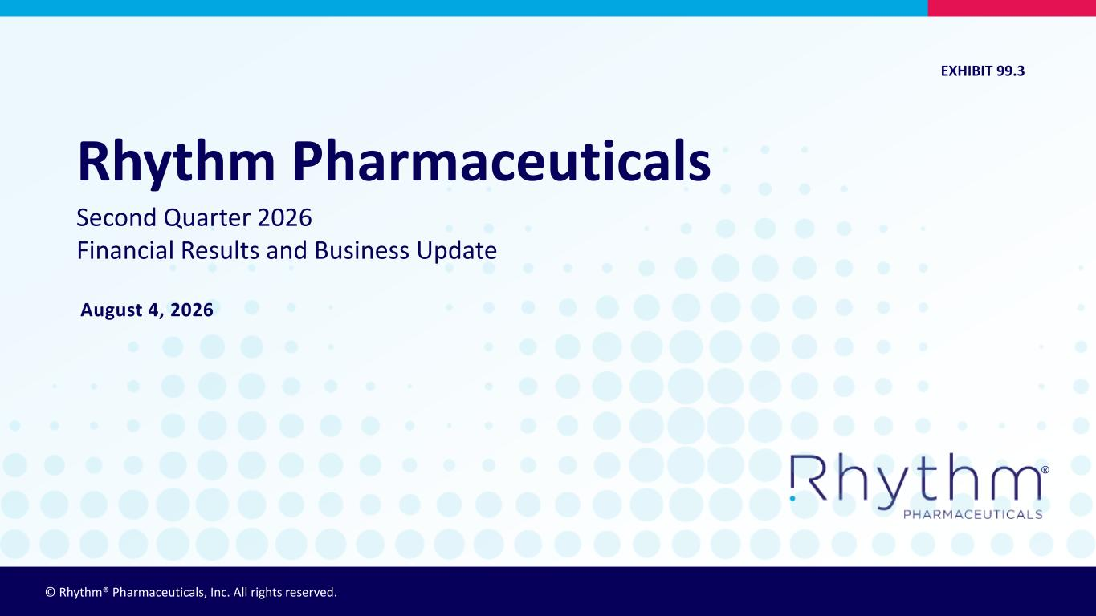

© Rhythm® Pharmaceuticals, Inc. All rights reserved. ® August 4, 2026 Rhythm Pharmaceuticals Second Quarter 2026 Financial Results and Business Update EXHIBIT 99.3


® 2 On Today’s Call • David Connolly, Vice President of Investor Relations and Corporate Communications • David Meeker, MD, Chair, President and Chief Executive Officer • Jennifer Lee, Executive Vice President, Head of North America • Yann Mazabraud, Executive Vice President, Head of International • Hunter Smith, Chief Financial Officer

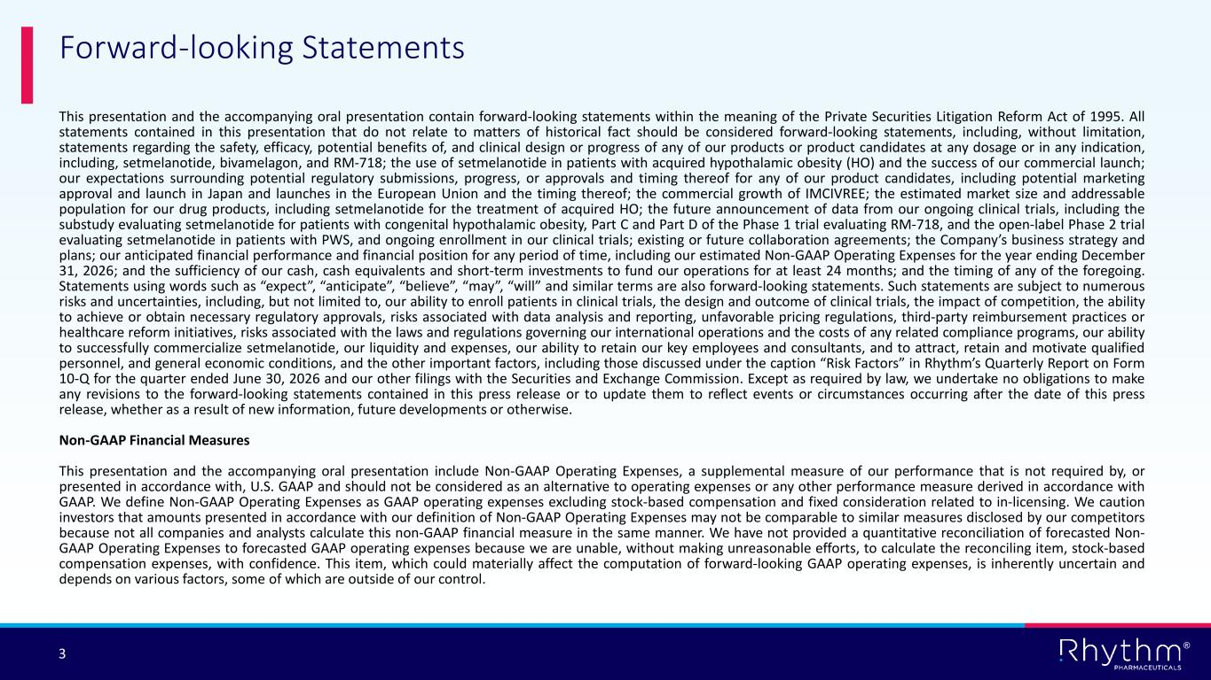
® 3 This presentation and the accompanying oral presentation contain forward-looking statements within the meaning of the Private Securities Litigation Reform Act of 1995. All statements contained in this presentation that do not relate to matters of historical fact should be considered forward-looking statements, including, without limitation, statements regarding the safety, efficacy, potential benefits of, and clinical design or progress of any of our products or product candidates at any dosage or in any indication, including, setmelanotide, bivamelagon, and RM-718; the use of setmelanotide in patients with acquired hypothalamic obesity (HO) and the success of our commercial launch; our expectations surrounding potential regulatory submissions, progress, or approvals and timing thereof for any of our product candidates, including potential marketing approval and launch in Japan and launches in the European Union and the timing thereof; the commercial growth of IMCIVREE; the estimated market size and addressable population for our drug products, including setmelanotide for the treatment of acquired HO; the future announcement of data from our ongoing clinical trials, including the substudy evaluating setmelanotide for patients with congenital hypothalamic obesity, Part C and Part D of the Phase 1 trial evaluating RM-718, and the open-label Phase 2 trial evaluating setmelanotide in patients with PWS, and ongoing enrollment in our clinical trials; existing or future collaboration agreements; the Company’s business strategy and plans; our anticipated financial performance and financial position for any period of time, including our estimated Non-GAAP Operating Expenses for the year ending December 31, 2026; and the sufficiency of our cash, cash equivalents and short-term investments to fund our operations for at least 24 months; and the timing of any of the foregoing. Statements using words such as “expect”, “anticipate”, “believe”, “may”, “will” and similar terms are also forward-looking statements. Such statements are subject to numerous risks and uncertainties, including, but not limited to, our ability to enroll patients in clinical trials, the design and outcome of clinical trials, the impact of competition, the ability to achieve or obtain necessary regulatory approvals, risks associated with data analysis and reporting, unfavorable pricing regulations, third-party reimbursement practices or healthcare reform initiatives, risks associated with the laws and regulations governing our international operations and the costs of any related compliance programs, our ability to successfully commercialize setmelanotide, our liquidity and expenses, our ability to retain our key employees and consultants, and to attract, retain and motivate qualified personnel, and general economic conditions, and the other important factors, including those discussed under the caption “Risk Factors” in Rhythm’s Quarterly Report on Form 10-Q for the quarter ended June 30, 2026 and our other filings with the Securities and Exchange Commission. Except as required by law, we undertake no obligations to make any revisions to the forward-looking statements contained in this press release or to update them to reflect events or circumstances occurring after the date of this press release, whether as a result of new information, future developments or otherwise. Non-GAAP Financial Measures This presentation and the accompanying oral presentation include Non-GAAP Operating Expenses, a supplemental measure of our performance that is not required by, or presented in accordance with, U.S. GAAP and should not be considered as an alternative to operating expenses or any other performance measure derived in accordance with GAAP. We define Non-GAAP Operating Expenses as GAAP operating expenses excluding stock-based compensation and fixed consideration related to in-licensing. We caution investors that amounts presented in accordance with our definition of Non-GAAP Operating Expenses may not be comparable to similar measures disclosed by our competitors because not all companies and analysts calculate this non-GAAP financial measure in the same manner. We have not provided a quantitative reconciliation of forecasted Non- GAAP Operating Expenses to forecasted GAAP operating expenses because we are unable, without making unreasonable efforts, to calculate the reconciling item, stock-based compensation expenses, with confidence. This item, which could materially affect the computation of forward-looking GAAP operating expenses, is inherently uncertain and depends on various factors, some of which are outside of our control. Forward-looking Statements

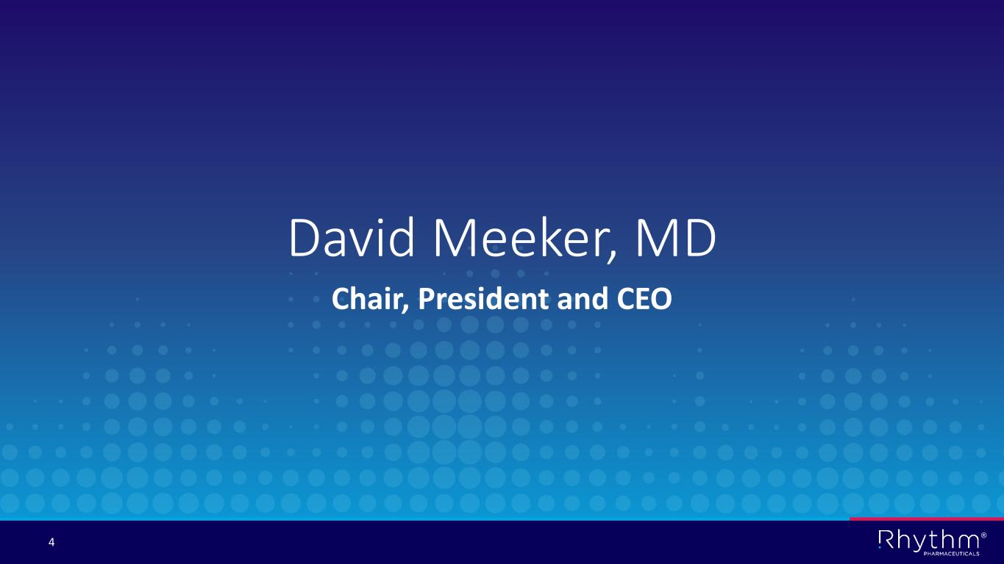
® 4 David Meeker, MD Chair, President and CEO

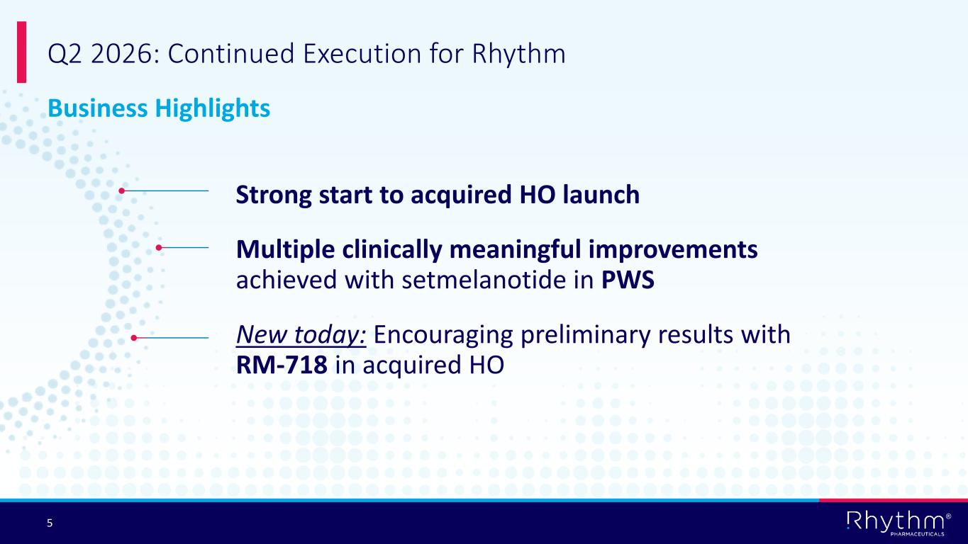
® 5 Strong start to acquired HO launch Multiple clinically meaningful improvements achieved with setmelanotide in PWS New today: Encouraging preliminary results with RM-718 in acquired HO Q2 2026: Continued Execution for Rhythm Business Highlights

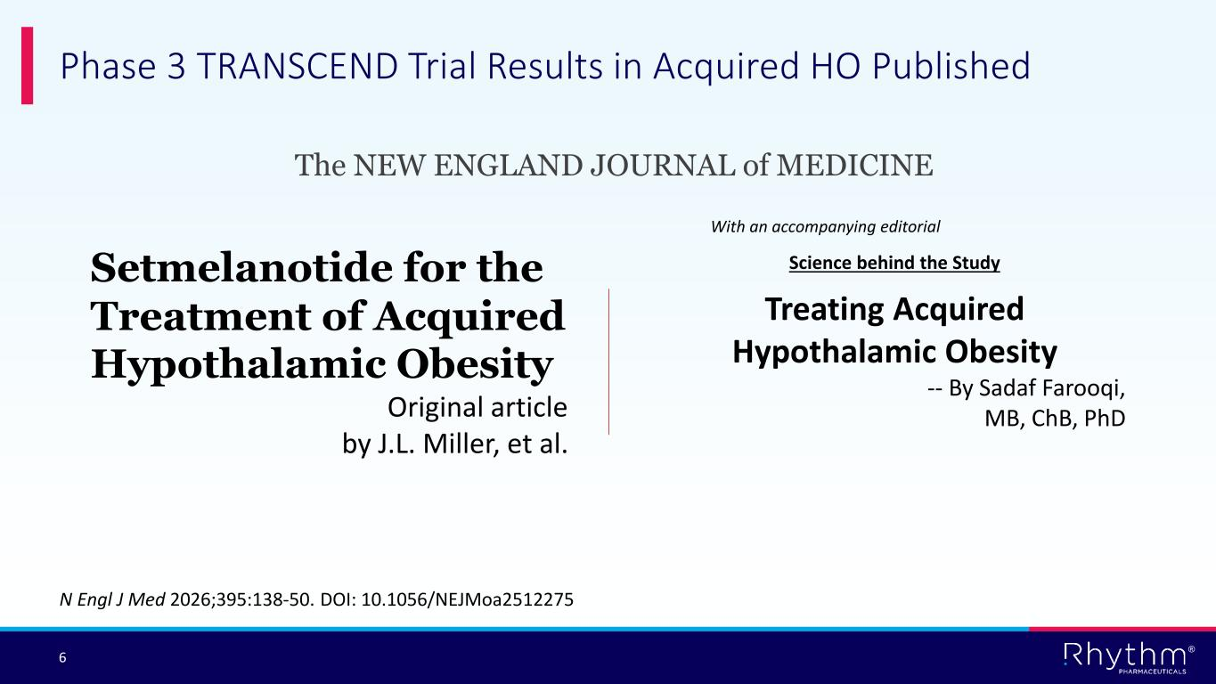
® 6 Phase 3 TRANSCEND Trial Results in Acquired HO Published Setmelanotide for the Treatment of Acquired Hypothalamic Obesity Original article by J.L. Miller, et al. N Engl J Med 2026;395:138-50. DOI: 10.1056/NEJMoa2512275 Treating Acquired Hypothalamic Obesity -- By Sadaf Farooqi, MB, ChB, PhD Science behind the Study With an accompanying editorial The NEW ENGLAND JOURNAL of MEDICINE

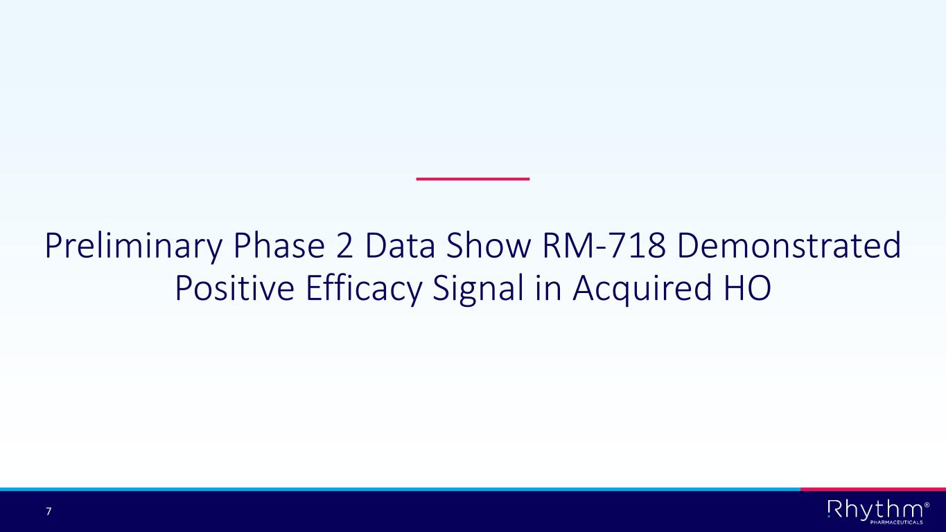
® 7 Preliminary Phase 2 Data Show RM-718 Demonstrated Positive Efficacy Signal in Acquired HO

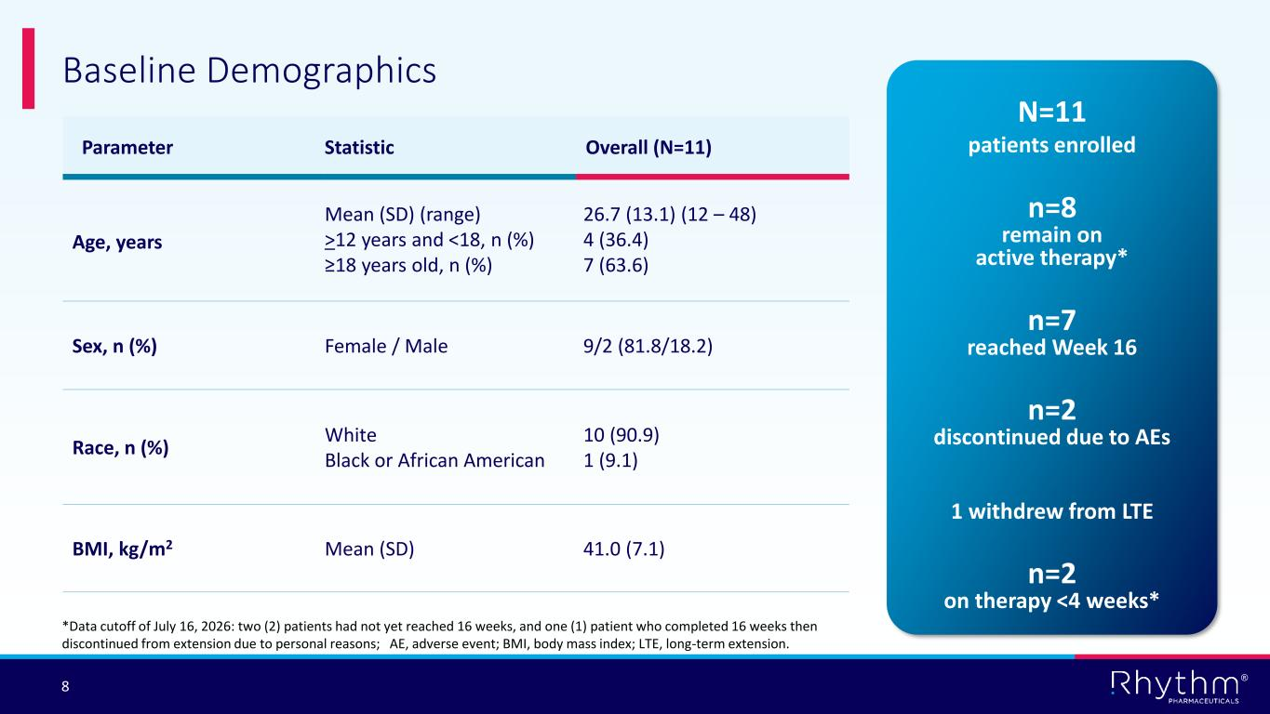
® 8 Baseline Demographics N=11 patients enrolledParameter Statistic Overall (N=11) Age, years Mean (SD) (range) >12 years and <18, n (%) ≥18 years old, n (%) 26.7 (13.1) (12 – 48) 4 (36.4) 7 (63.6) Sex, n (%) Female / Male 9/2 (81.8/18.2) Race, n (%) White Black or African American 10 (90.9) 1 (9.1) BMI, kg/m2 Mean (SD) 41.0 (7.1) n=2 discontinued due to AEs n=7 reached Week 16 n=8 remain on active therapy* *Data cutoff of July 16, 2026: two (2) patients had not yet reached 16 weeks, and one (1) patient who completed 16 weeks then discontinued from extension due to personal reasons; AE, adverse event; BMI, body mass index; LTE, long-term extension. n=2 on therapy <4 weeks* 1 withdrew from LTE

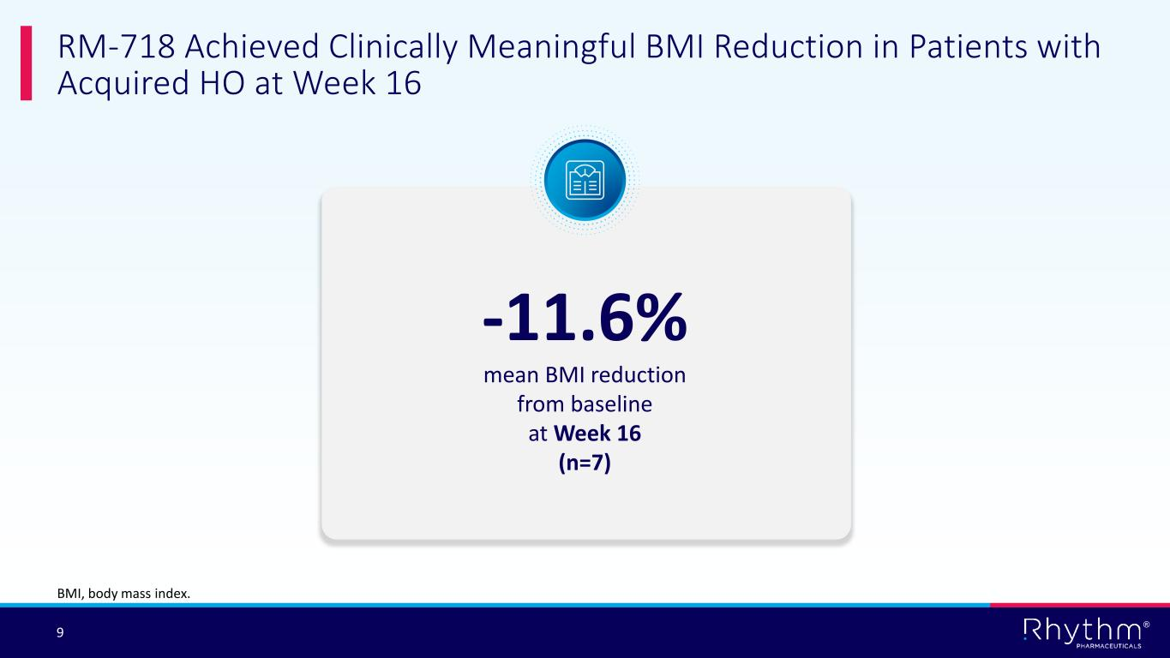
® 9 RM-718 Achieved Clinically Meaningful BMI Reduction in Patients with Acquired HO at Week 16 -11.6% mean BMI reduction from baseline at Week 16 (n=7) BMI, body mass index.

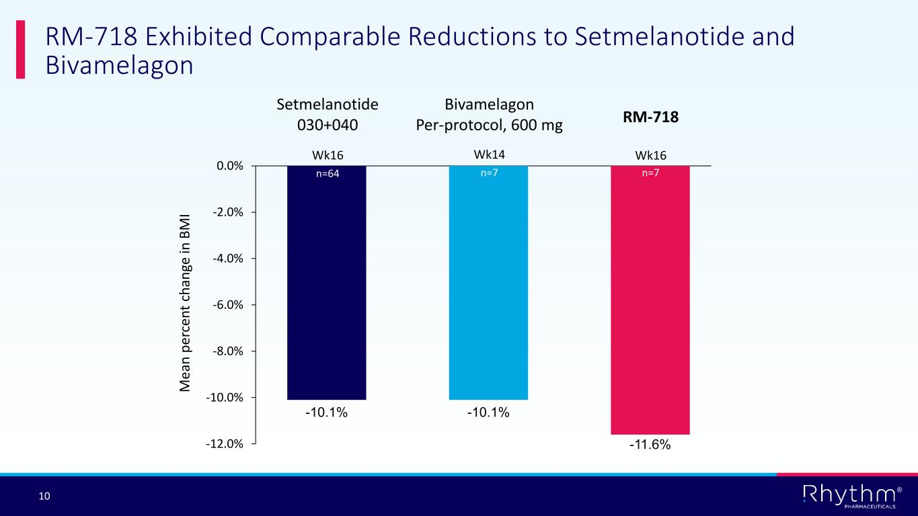
® 10 RM-718 Exhibited Comparable Reductions to Setmelanotide and Bivamelagon -10.1% -10.1% -11.6%-12.0% -10.0% -8.0% -6.0% -4.0% -2.0% 0.0% Setmelanotide 030+040 Bivamelagon Per-protocol, 600 mg RM-718 Wk16 Wk16 M ea n p er ce n t ch an ge in B M I Wk14 n=64 n=7n=7

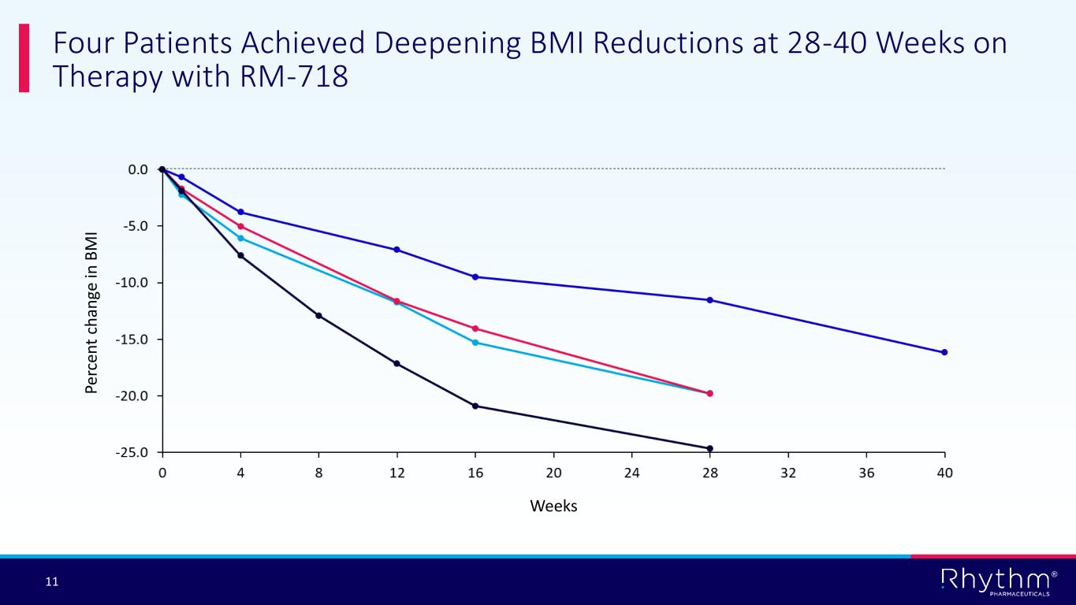
® 11 Four Patients Achieved Deepening BMI Reductions at 28-40 Weeks on Therapy with RM-718​ Pe rc en t ch an ge in B M I Weeks

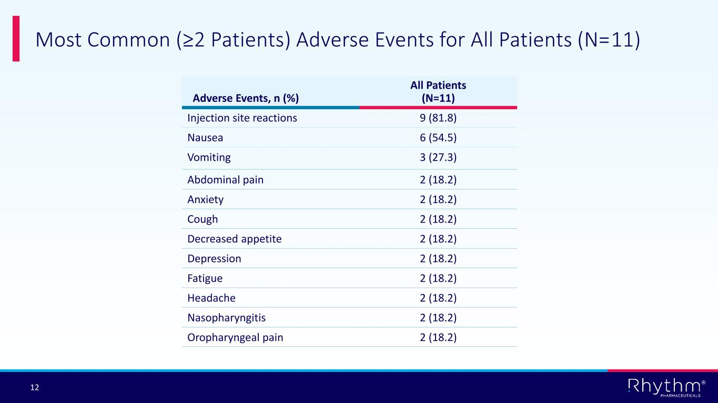
® 12 Most Common (≥2 Patients) Adverse Events for All Patients (N=11) Adverse Events, n (%) All Patients (N=11) Injection site reactions 9 (81.8) Nausea 6 (54.5) Vomiting 3 (27.3) Abdominal pain 2 (18.2) Anxiety 2 (18.2) Cough 2 (18.2) Decreased appetite 2 (18.2) Depression 2 (18.2) Fatigue 2 (18.2) Headache 2 (18.2) Nasopharyngitis 2 (18.2) Oropharyngeal pain 2 (18.2)

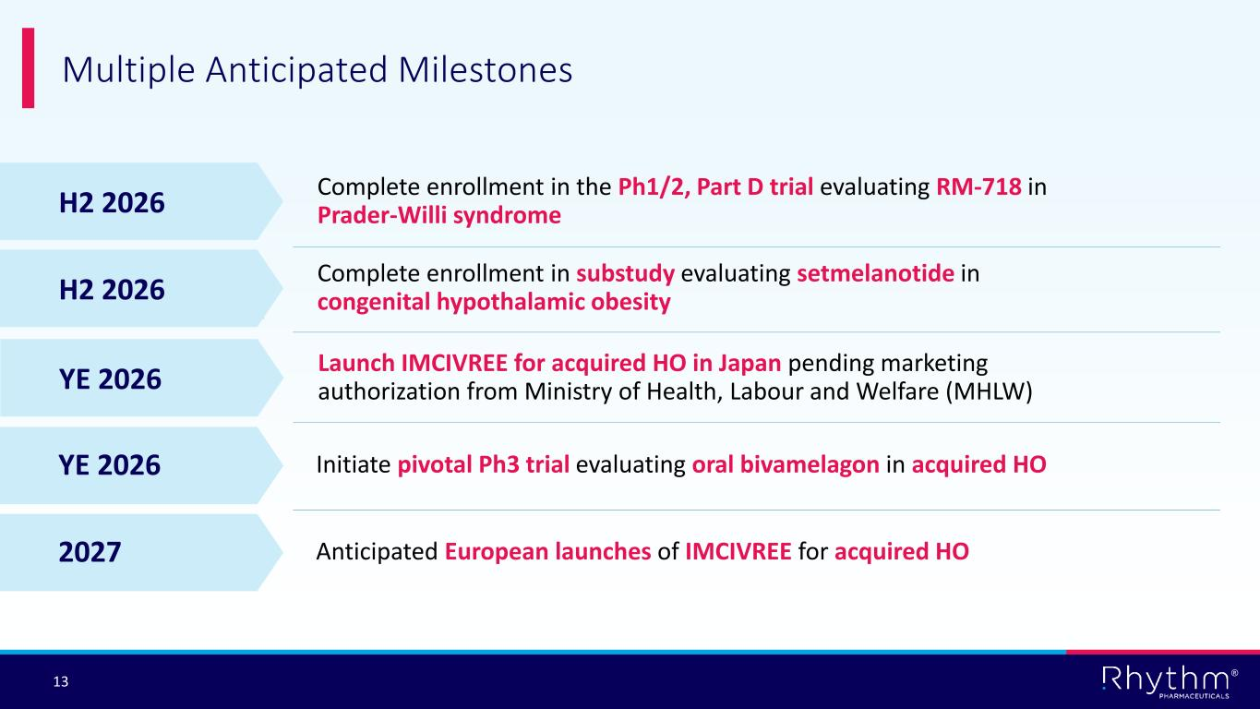
® 13 Multiple Anticipated Milestones Initiate pivotal Ph3 trial evaluating oral bivamelagon in acquired HOYE 2026 YE 2026 Launch IMCIVREE for acquired HO in Japan pending marketing authorization from Ministry of Health, Labour and Welfare (MHLW) H2 2026 Complete enrollment in substudy evaluating setmelanotide in congenital hypothalamic obesity H2 2026 Complete enrollment in the Ph1/2, Part D trial evaluating RM-718 in Prader-Willi syndrome Anticipated European launches of IMCIVREE for acquired HO2027


® 14 Jennifer Lee EVP, Head of North America

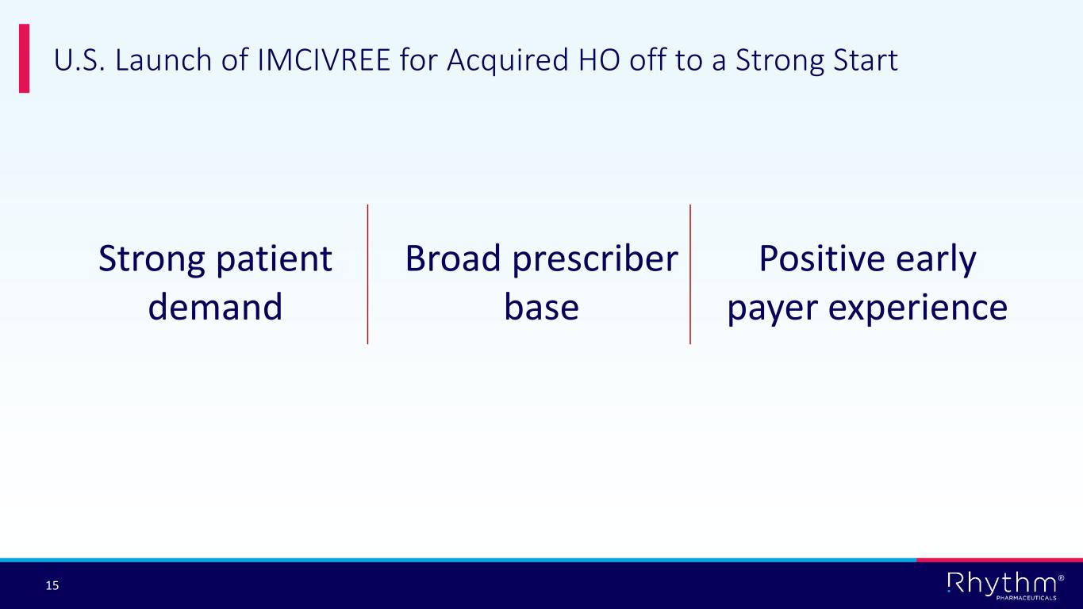
® 15 U.S. Launch of IMCIVREE for Acquired HO off to a Strong Start Strong patient demand Broad prescriber base Positive early payer experience

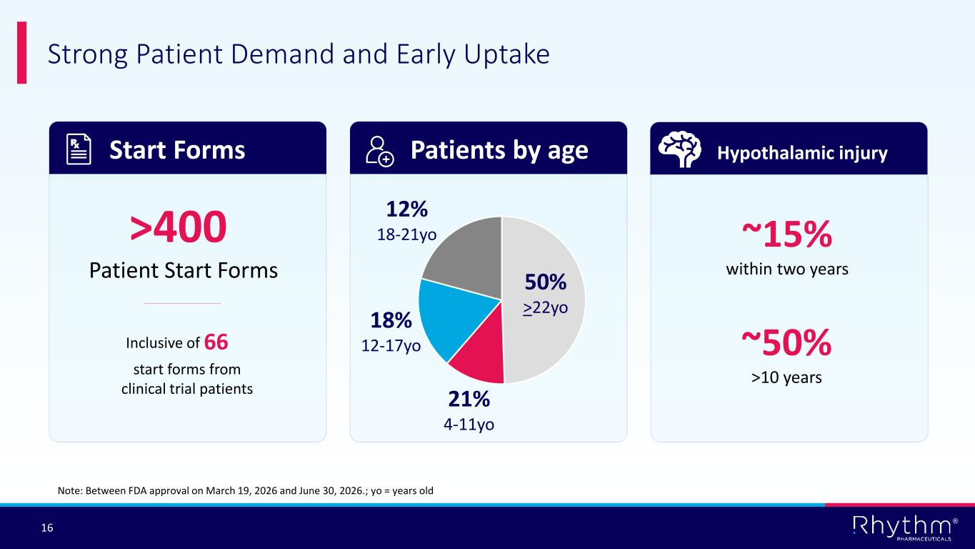
® 16 Strong Patient Demand and Early Uptake Start Forms Patients by age Hypothalamic injury Note: Between FDA approval on March 19, 2026 and June 30, 2026.; yo = years old ~15% within two years ~50% > ​10 years >400 Patient Start Forms 66 start forms from clinical trial patients 12% 18-21yo 18% 12-17yo 21% 4-11yo Inclusive of 50% >22yo

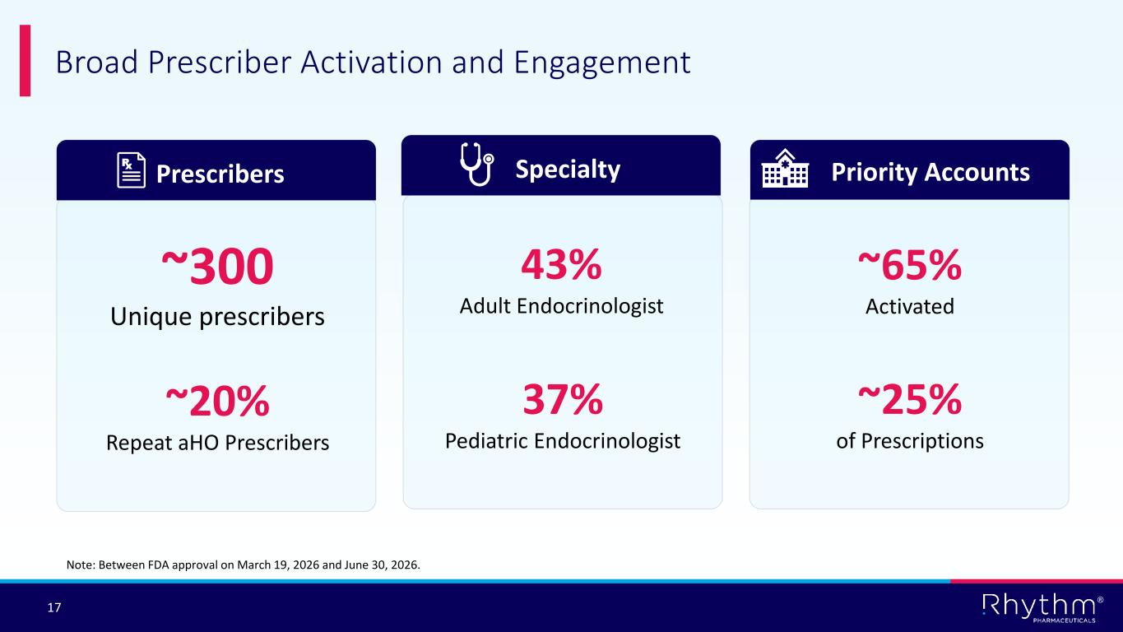
® 17 Broad Prescriber Activation and Engagement Prescribers Specialty Priority Accounts Note: Between FDA approval on March 19, 2026 and June 30, 2026. ~300 Unique prescribers ~65% Activated ~25% of Prescriptions 43% Adult Endocrinologist 37% Pediatric Endocrinologist ~20% Repeat aHO Prescribers

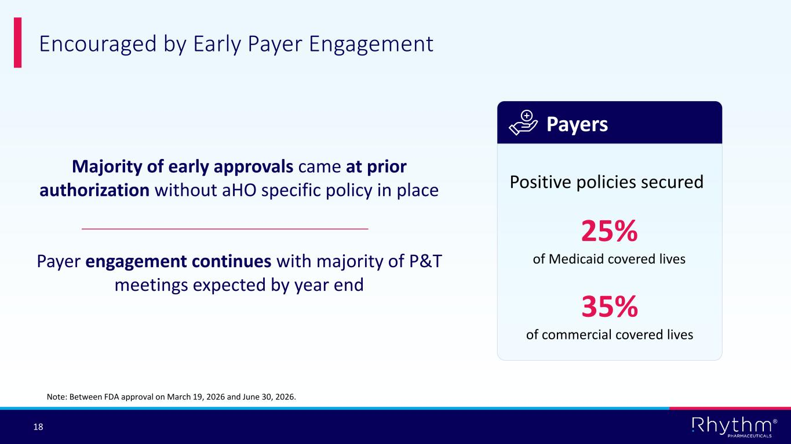
® 18 Encouraged by Early Payer Engagement Note: Between FDA approval on March 19, 2026 and June 30, 2026. Payers Positive policies secured 25% of Medicaid covered lives 35% of commercial covered lives Majority of early approvals came at prior authorization without aHO specific policy in place Payer engagement continues with majority of P&T meetings expected by year end

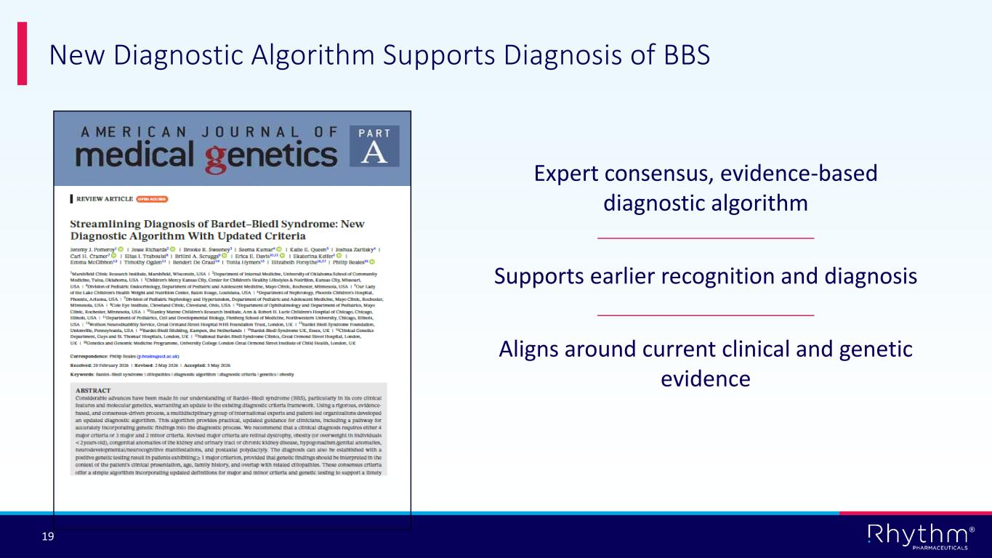
® 19 Expert consensus, evidence-based diagnostic algorithm Supports earlier recognition and diagnosis Aligns around current clinical and genetic evidence New Diagnostic Algorithm Supports Diagnosis of BBS

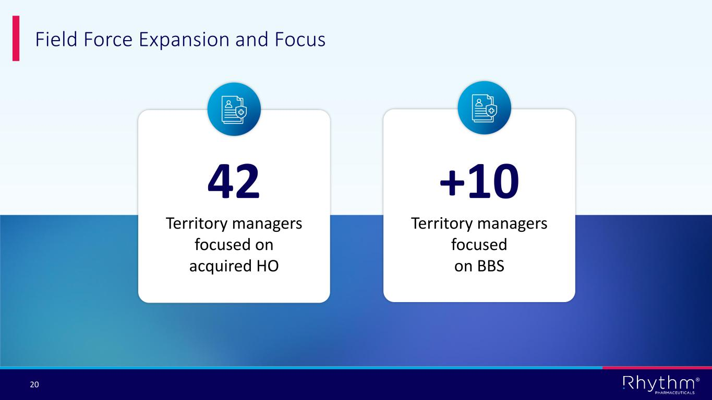
® 20 Field Force Expansion and Focus +10 Territory managers focused on BBS 42 Territory managers focused on acquired HO

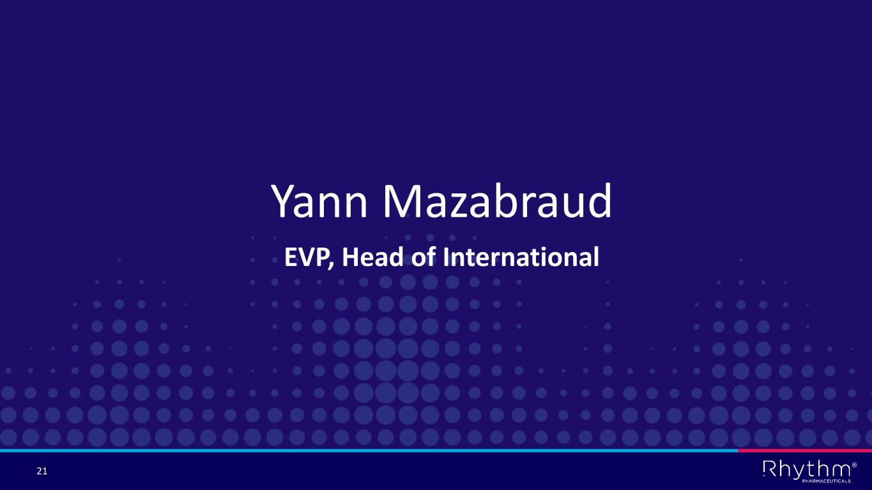
® 21 Yann Mazabraud EVP, Head of International

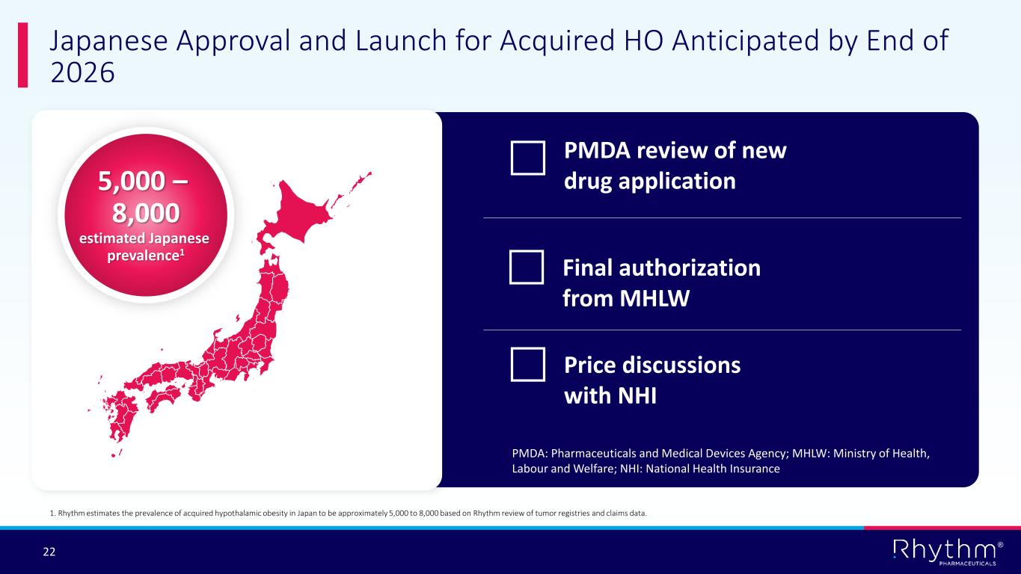
® 22 Japan map with prevalence Japanese Approval and Launch for Acquired HO Anticipated by End of 2026 1. Rhythm estimates the prevalence of acquired hypothalamic obesity in Japan to be approximately 5,000 to 8,000 based on Rhythm review of tumor registries and claims data. 5,000 – 8,000 estimated Japanese prevalence1 PMDA review of new drug application Final authorization from MHLW Price discussions with NHI PMDA: Pharmaceuticals and Medical Devices Agency; MHLW: Ministry of Health, Labour and Welfare; NHI: National Health Insurance

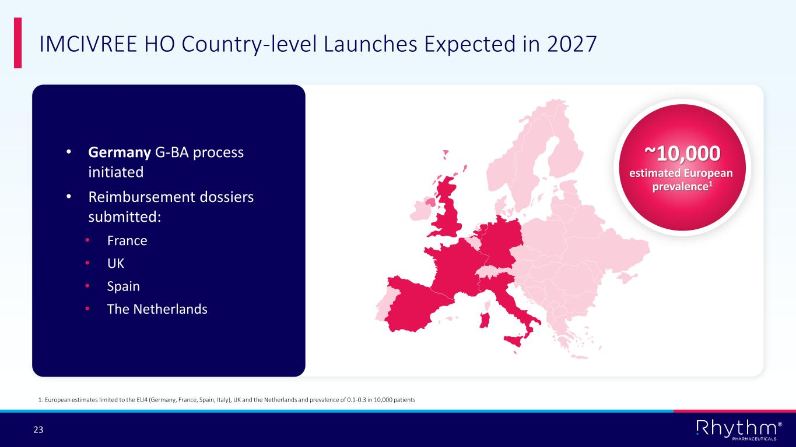
® 23 IMCIVREE HO Country-level Launches Expected in 2027 1. European estimates limited to the EU4 (Germany, France, Spain, Italy), UK and the Netherlands and prevalence of 0.1-0.3 in 10,000 patients ~10,000 estimated European prevalence1 • Germany G-BA process initiated • Reimbursement dossiers submitted: • France • UK • Spain • The Netherlands


® 24 Hunter Smith Chief Financial Officer

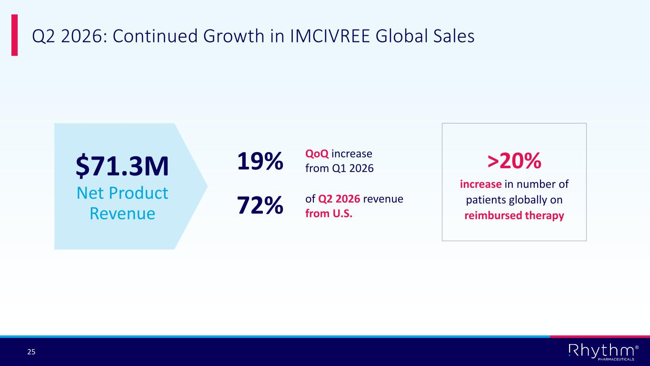
® 25 Q2 2026: Continued Growth in IMCIVREE Global Sales 19% QoQ increase from Q1 2026 72% of Q2 2026 revenue from U.S. $71.3M Net Product Revenue >20% increase in number of patients globally on reimbursed therapy

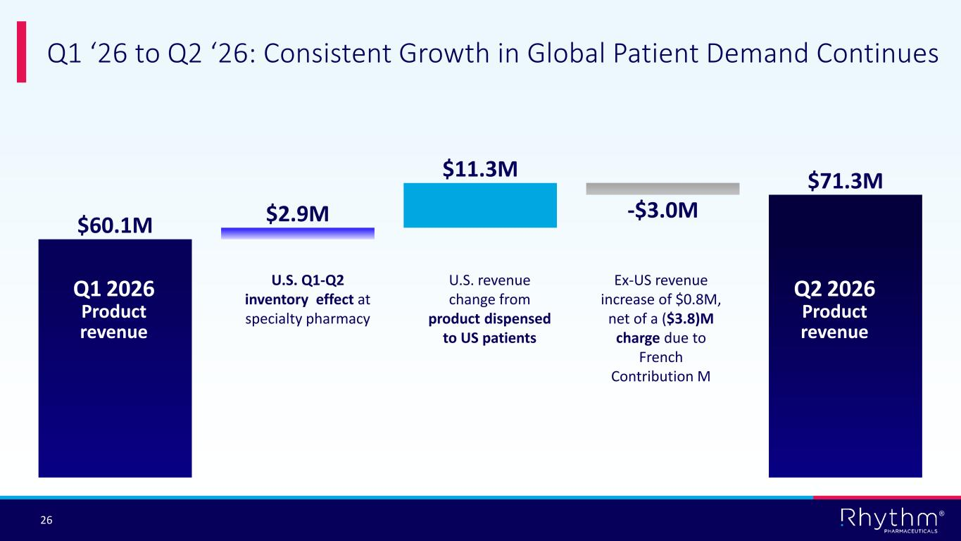
® 26 Q1 ‘26 to Q2 ‘26: Consistent Growth in Global Patient Demand Continues $60.1M $2.9M $11.3M -$3.0M $71.3M Q1 2026 Product revenue Q2 2026 Product revenue U.S. Q1-Q2 inventory effect at specialty pharmacy Ex-US revenue increase of $0.8M, net of a ($3.8)M charge due to French Contribution M U.S. revenue change from product dispensed to US patients

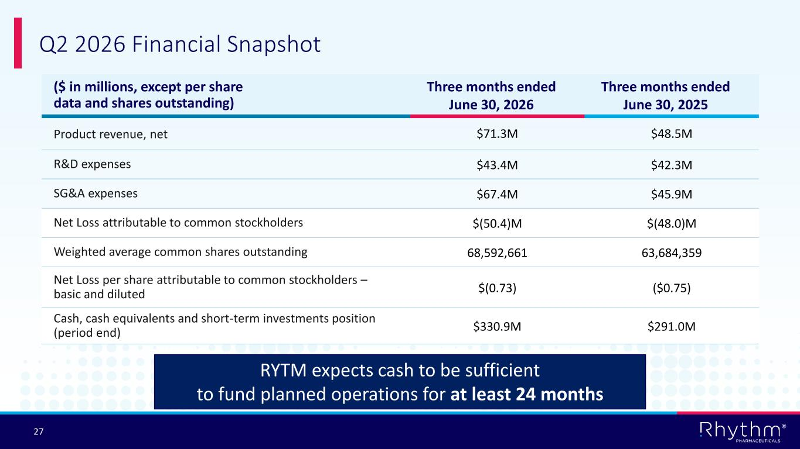
® 27 Q2 2026 Financial Snapshot ($ in millions, except per share data and shares outstanding) Three months ended June 30, 2026 Three months ended June 30, 2025 Product revenue, net $71.3M $48.5M R&D expenses $43.4M $42.3M SG&A expenses $67.4M $45.9M Net Loss attributable to common stockholders $(50.4)M $(48.0)M Weighted average common shares outstanding 68,592,661 63,684,359 Net Loss per share attributable to common stockholders – basic and diluted $(0.73) ($0.75) Cash, cash equivalents and short-term investments position (period end) $330.9M $291.0M RYTM expects cash to be sufficient to fund planned operations for at least 24 months

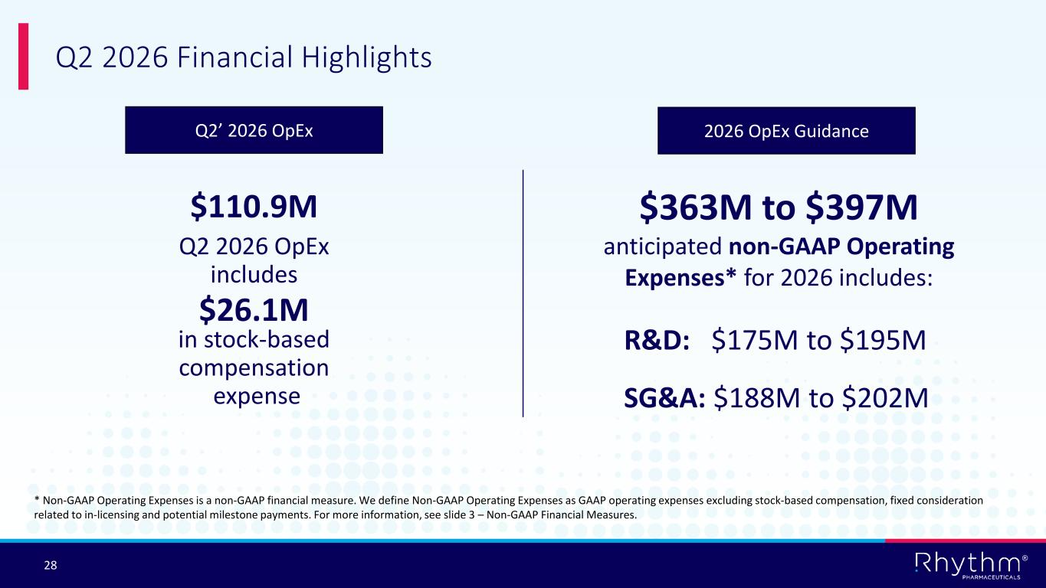
® 28 $110.9M Q2 2026 OpEx includes $26.1M in stock-based compensation expense Q2 2026 Financial Highlights * Non-GAAP Operating Expenses is a non-GAAP financial measure. We define Non-GAAP Operating Expenses as GAAP operating expenses excluding stock-based compensation, fixed consideration related to in-licensing and potential milestone payments. For more information, see slide 3 – Non-GAAP Financial Measures. $363M to $397M anticipated non-GAAP Operating Expenses* for 2026 includes: R&D: $175M to $195M SG&A: $188M to $202M Q2’ 2026 OpEx 2026 OpEx Guidance


® 29 Concluding Comments

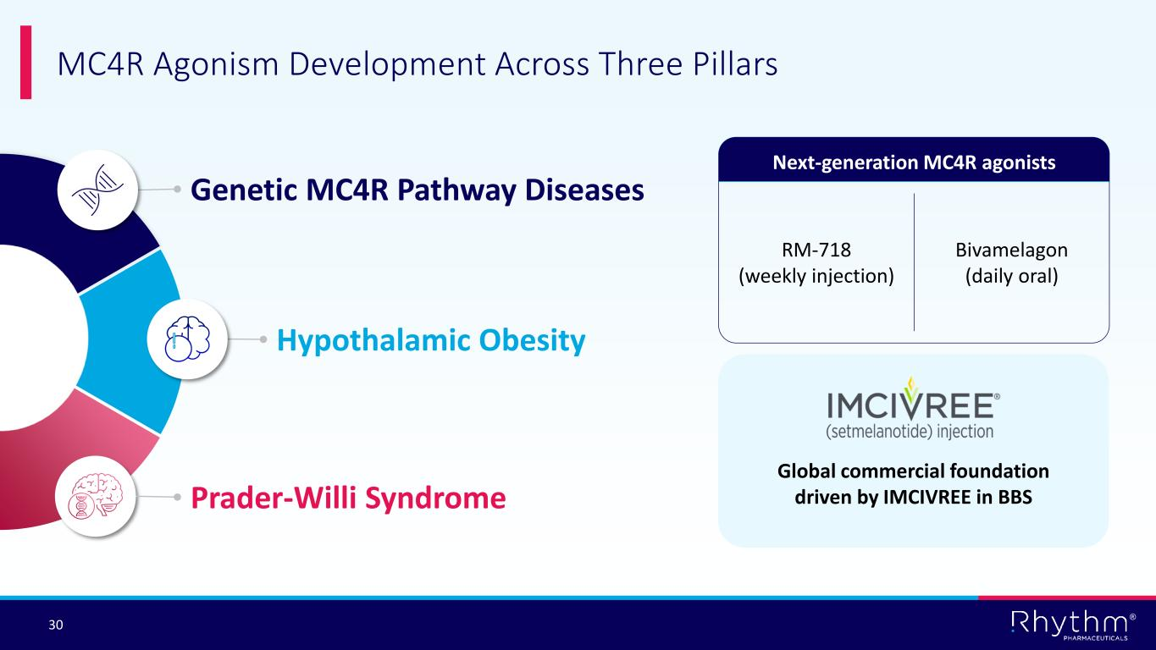
® 30 MC4R Agonism Development Across Three Pillars Global commercial foundation driven by IMCIVREE in BBS Next-generation MC4R agonists RM-718 (weekly injection) Bivamelagon (daily oral) Genetic MC4R Pathway Diseases Prader-Willi Syndrome Hypothalamic Obesity


® 31 Questions

